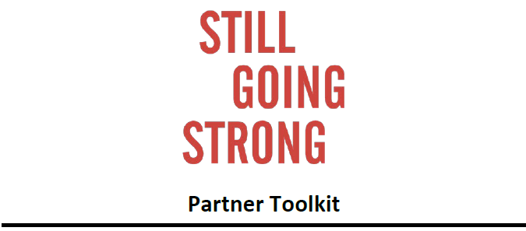
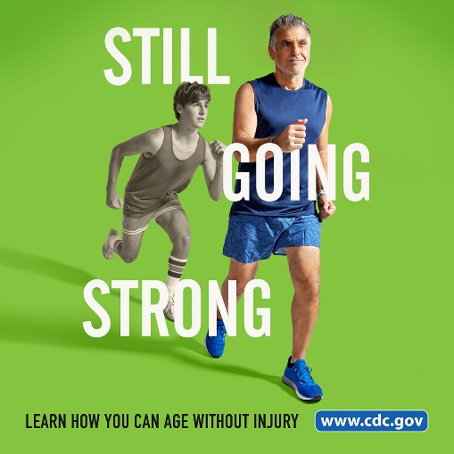
Still Going Strong is an empowering awareness campaign from CDC’s National Center for Injury Prevention and Control that encourages older adults (ages 65 and older) to age safely. This campaign highlights the benefits of staying active and other simple steps older adults can take to reduce their risk of common injuries, such as a traumatic brain injury (TBI) or bone fracture, that can result from a fall or motor vehicle crash. The campaign launched in May 2021 and was updated in September 2023.
Adults 65 and older are one of the fastest-growing demographics in the United States. Increasing awareness of injury prevention among older adults and their caregivers helps them understand that many injuries are preventable!
This toolkit is intended to help partner organizations (e.g., state and local health departments, community organizations) promote older adult injury prevention and motivate older adults to stay safe and independent longer. Still Going Strong content is free to use. We encourage you to share campaign messages and resources through your organization’s communication channels.
What’s included:
- Partner Letter
- Quick Facts
- Key Messages
- Social Media Posts
- Multimedia Assets

Still Going Strong materials are available for download at: www.cdc.gov/still-going-strong/campaign-resources/index.html

Partner Letter
You can share the following letter in communications outreach to your partner organizations to encourage participation in the Still Going Strong campaign.

Sample Letter
Still Going Strong is a campaign to educate adults ages 65 and older (older adults), and those that care for them, about common injuries that can be prevented as they age and specific steps they can take to reduce their risk of injury. The campaign was designed by CDC’s National Center for Injury Prevention and Control. Still Going Strong empowers older adults to stay safe without sacrificing their favorite hobbies and activities. It is possible to age without injury and maintain quality of life.
As an influential organization that serves older adults, we welcome your support to champion this campaign and help spread the word to older adults who are “still going strong.” This campaign provides the latest data and audience-tested creative resources to use in your own outreach efforts.
The Still Going Strong partner toolkit is available for download. Visit www.cdc.gov/still-going-strong/about/index.html to learn more.

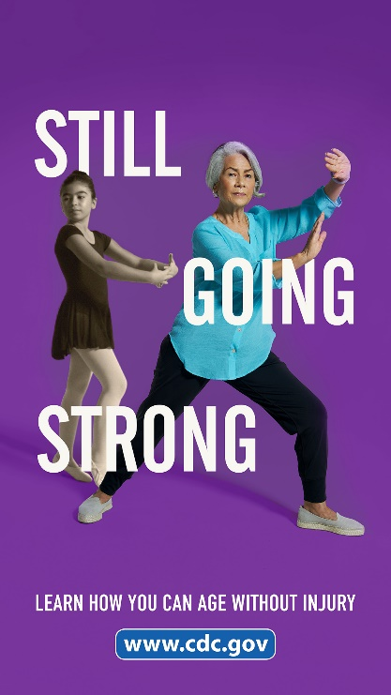
Quick Facts
Older adults are at greater risk for serious injuries from falls, motor vehicle crashes, and social isolation compared to other age groups. The following facts may encourage older adults and their caregivers to learn more.
- Falls and motor vehicle crashes are leading causes of injury death among older adults.¹
- More than 1 in 4 older adults report falling, resulting in 37 million falls each year.²
- Every year, nearly 41,000 older adults die due to a fall.³
- Fall death rates have increased about 40% in the last decade.³
- Every year, 8,500 older adults die in car crashes, and 200,000 are treated in emergency departments for crash-related injuries.¹
- Every day, 23 older adults are killed and almost 540 are injured in crashes.¹
- Falls and motor vehicle crashes are common causes of traumatic brain injury (TBI) among older adults.⁴
- Older adults are more likely to have a hospital stay and die from a traumatic brain injury (TBI) compared to all other age groups.⁴
- Nearly 1 in 4 older Americans is socially isolated.⁵
- Social isolation and loneliness have been linked to increased risk for heart disease and stroke, type 2 diabetes, depression and anxiety, addiction, suicidal ideation and self-harm, dementia, and early death.⁶

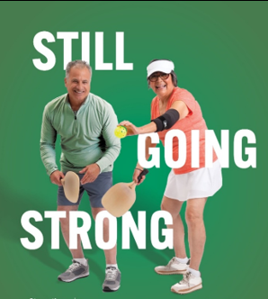
Key Messages

Stay Active. Speak Up. Take Action.
Injuries are not a natural part of aging—they can be prevented. Encourage older adults in your communities to take a proactive role in staying healthy and safe by considering the following key messages for your communication materials.
- Injuries from falls and car crashes are common in older age, but they are preventable. There are simple steps you can take to reduce your risk of injury and stay independent longer.
- Talk openly with your loved ones and doctor (or other healthcare provider) about your fall risk, driving fitness, social and emotional health, and ways to prevent injury.
- Discuss medical conditions with your doctor to determine if they may increase your risk of falling or affect your driving.
- Side effects of medicines may increase your chances of a fall or car crash. Have your doctor or pharmacist review all the medicines you take, even over-the-counter medications and vitamins.
Fall specific messages
- Tell your doctor if you have fallen, if you feel unsteady when standing or walking, or if you are afraid you might fall.
- Most falls happen at home. The STEADI Home Safety Tour shows how to make your home safer by making small changes, like adding more or brighter light bulbs and removing trip hazards, such as throw rugs and clutter.
- Have your eyes checked once a year and wear corrective lenses as needed.
- Stay active to maintain your strength and balance, which lowers your chances of falling.
TBI specific messages
- Getting care from your doctor after a concussion or other TBI can help speed your recovery.
- Get checked for a TBI if you have fallen or were in a car crash and hit your head. This is especially important among older adults who are taking blood thinners.
- TBIs may be missed or misdiagnosed because symptoms of TBI overlap with other medical conditions that are common among older adults.

Social connectedness/isolation specific messages
- Identify challenges you may face connecting with others. Talk with a friend, family member, or doctor about overcoming these barriers to maintain your health and independence.
- Share the activities you enjoy with those you love, to stay active and connected.
- Social connectedness can improve life expectancy, health outcomes, and overall well-being.
- Stay connected with family and friends through in-person interactions, phone calls, and social media.

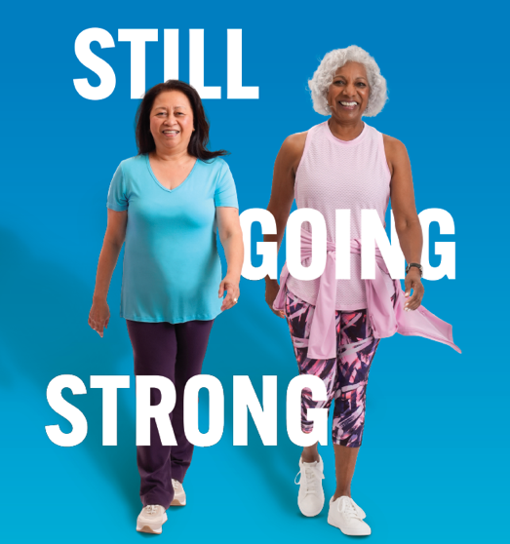
Social Media Posts
You can share the Still Going Strong campaign on Facebook, Instagram, LinkedIn, X (formerly Twitter), and other platforms. Use the hashtag #StillGoingStrong and tag @CDC. Sample posts are below and can be paired with campaign specific social media graphics, linked below.

Sample posts for older adults
- Common injuries among adults ages 65 and older are preventable. Small steps can make a big difference in your health and independence. Find out how: www.cdc.gov/still-going-strong/older-adults/index.html #StillGoingStrong
- Growing older doesn’t mean giving up the activities you have always enjoyed. Learn tips to age safely, without injury. Visit: www.cdc.gov/still-going-strong/older-adults/index.html #StillGoingStrong
- Sharing activities that you enjoy with those you love helps you stay active and connected. Learn more: www.cdc.gov/still-going-strong/hcp/info/index.html #StillGoingStrong

Sample posts for caregivers
- Older adults are more active & mobile than ever, but an injury from a fall or car crash can decrease their independence. Learn how #StillGoingStrong helps older adults prevent injuries as they age. www.cdc.gov/still-going-strong/caregivers/index.html
- Adults ages 65+ have a higher risk of injury due to a fall or car crash. Learn simple steps you and your loved ones can take to age without injury. www.cdc.gov/still-going-strong/caregivers/index.html #StillGoingStrong
- If an older adult in your life has fallen and hit their head, ask their doctor to check for TBI. TBI signs and symptoms may be missed or misdiagnosed as they can overlap with other medical conditions. www.cdc.gov/still-going-strong/caregivers/index.html #StillGoingStrong

Sample posts for healthcare providers
- Ask your patients ages 65+ if they have concerns about falling or driving safely. Review their OTC & Rx meds and check for side effects that could increase the chance for falls or car crashes. https://tinyurl.com/2s9nrexk #StillGoingStrong
- Ask your patients ages 65+ how often they engage with others and if they’re lonely. Social isolation can have significant adverse effects on physical and emotional health. https://tinyurl.com/ydd7ppw2 #StillGoingStrong
- Check your older patients for signs and symptoms of a TBI if they have fallen or were in a car crash. This is especially important among older adults who are taking blood thinners. https://tinyurl.com/ydd2rz4v #StillGoingStrong
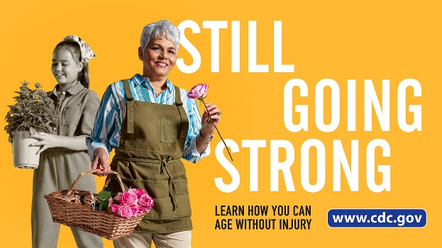
Multimedia Assets
Still Going Strong creative campaign assets are available for free download.
- Full- and half-page print ads
- Videos
- Radio spots
- Social media images
Please use this toolkit in communication and outreach efforts. Access multimedia library: https://www.cdc.gov/still-going-strong/campaign-resources/index.html

References
- Centers for Disease Control and Prevention, National Center for Injury Prevention and Control. Web-based Injury Statistics Query and Reporting System (WISQARS). Atlanta (GA). Accessed 2023.
- Kakara R, Bergen G, Burns E, Stevens M. Nonfatal and Fatal Falls Among Adults Aged ≥65 Years—United States, 2020–2021. MMWR Morb Mortal Wkly Rep 2023;72:938–943. DOI: 10.15585/mmwr.mm7235a1.
- Centers for Disease Control and Prevention. National Center for Health Statistics: Mortality Data on CDC Wide-ranging Online Data for Epidemiologic Research (WONDER). Accessed 2022.
- Centers for Disease Control and Prevention, National Center for Injury Prevention and Control. Get the Facts About TBI.
- National Academies of Sciences, Engineering, and Medicine. Social Isolation and Loneliness in Older Adults: Opportunities for the Health Care System. The National Academies Press; 2020. DOI: 10.17226/25663
- Centers for Disease Control and Prevention, National Center for Chronic Disease Prevention and Health Promotion. Health Risks of Social Isolation and Loneliness.

