Appendix

A.1 Summary of the Payments Made on Behalf of Participants in the Considered Nationwide DPP Expansion by the Office of the Actuary Analysis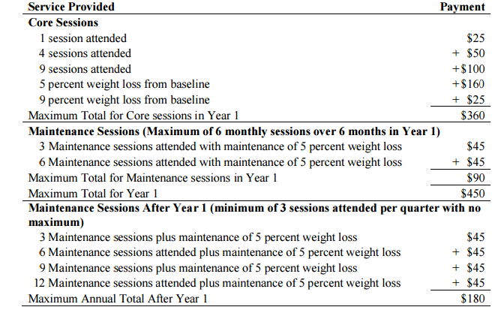
Source: <https://www.cms.gov/Research-Statistics-Data-and-Systems/Research/ActuarialStudies/Downloads/Diabetes-Prevention-Certification-2016-03-14.pdf>

A.2 WTP Questionnaire Tree: Are You Willing to Pay $ Monthly for the Delivery Mechanism Described?
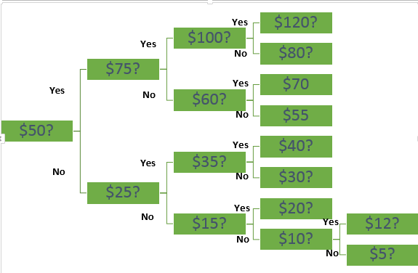

If the responder answers yes to the first question (s)he is asked about his willingness to pay for a higher amount. If (s)he answers no to the first question, a lower amount is offered.
In this setup, each respondent provides the following information set:
1. If the individual answers yes to the first question and no to the second, then t2 > t1. In this case, we can infer that t1 ≤ WTP < t2.
Pr(y,n)=Pr(bid1$≤xβ+u<$bid2)=$Φ\left(x\frac{β}{σ}-\frac{bid1}{σ}\right)-Φ\left(x\frac{β}{σ}-\frac{bid2}{σ}\right)$
2. If the individual answers yes to the first question and yes to the second, then t2 ≤ WTP < ∞.
Pr(y,y)=Pr($xβ+u$>bid1, $xβ+u≥$bid2)=$Φ\left(x\frac{β}{σ}-\frac{bid2}{σ}\right)$
3. If the individual answers no to the first question and yes to the second, then t2 < t1. In this case, we have that t2 ≤ WTP < t1.
Pr(n,y)=Pr(bid2$≤xβ+u<$bid1)=$Φ\left(x\frac{β}{σ}-\frac{bid2}{σ}\right)-Φ\left(x\frac{β}{σ}-\frac{bid1}{σ}\right)$
4. If the individual answers no to the first and second questions, then 0 < WTP < t2.
Pr(n,n)=Pr($xβ+u<$bid1, $xβ+u$ $≤$bid2)=$1-Φ\left(x\frac{β}{σ}-\frac{bid2}{σ}\right)$

A.3 Type of Programs Offered by Providers Who Responded to Our Questionnaire
 |  | Any other weight loss program
Program | Offered? | No | Yes | Total
DPP | No | 12 | 9 | 21
 | Yes | 5 | 3 | 8
 | Total | 17 | 12 | 29
Note: DPP = Diabetes Prevention Program

A.4 Alternative Supply Elicitation Question
Suppose your potential funding source (e.g. NC Division of Public Health) sets a flat rate reimbursement rate of:
Total Amount $ per Course (16 sessions) | Would you chose to provide the service? (yes/no/don’t know) | How many people would you be able to enroll at this level of founding? (min-max range)
1,000 | 6/17/5 | 2–60
2,000 | 7/16/5 | 4–60
5,000 | 15/8/5 | 8–100
7,000 | 18/4/6 | 10–140
10,000 | 22/0/6 | 10–500
Note: Only 28 individuals answered this section. One person left all fields blank; blank fields could be interpreted as “not known.”

