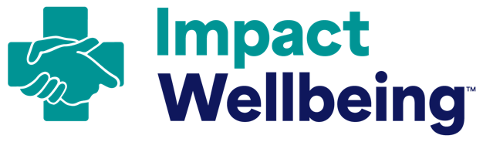
Guide to Update and Remove Intrusive
and Stigmatizing Questions

How to use this guide:
- Select one of the following three approaches to update the questions in your organization’s credentialing, review, and application forms.
- Note that this guide draws from the Dr. Lorna Breen Heroes’ Foundation’s toolkit to Remove Intrusive Mental Health Questions from Credentialing Applications.

Three options to change application language:
Option 1: Ask one question consistent with the Federation of State Medical Boards’ Recommended Language that addresses all mental and physical health conditions as one. Avoid added explanations, asterisks, or fine print.
Use the following language: “Are you currently suffering from any condition for which you are not being appropriately treated that impairs your judgment or that would otherwise adversely affect your ability to practice medicine in a competent, ethical, and professional manner? (Yes/No)”

Option 2: Refrain from asking probing questions about an applicant’s health altogether.

Option 3: Implement an Attestation Model, like that used in North Carolina and Mississippi. This uses supportive language around mental health from the Federation of State Medical Boards. It holds healthcare workers accountable to their wellbeing, making it clear that their self-care is patient care. Offer “safe haven” non-reporting options to healthcare workers who are:
- under treatment, and
- in good standing with a recognized physician health program or other appropriate
care provider.

Attestation Model Language Example from North Carolina:
Important: The Board recognizes that licensees encounter health conditions, including those involving mental health and substance use disorders, just as their patients and other healthcare providers do. The Board expects its licensees to address their health concerns and ensure patient safety. Options include seeking medical care, self-limiting the licensee’s medical practice, and anonymously self-referring to the NC Physicians Health Program, a physician advocacy organization dedicated to improving the health and wellness of medical professionals in a confidential manner. The failure to adequately address a health condition, where the licensee is unable to practice medicine within reasonable skill and safety to patients, can result in the Board taking action against the license to practice medicine.

ALL IN: WellBeing First for Healthcare [2022]. Remove intrusive mental health questions from credentialing applications. Charlottesville, VA: The Dr. Lorna Breen Heroes’ Foundation.
Federation of State Medical Boards [2018]. Physician wellness and burnout: Report and recommendations of the workgroup on physician wellness and burnout. Euless, TX: Federation of State Medical Boards.
North Carolina Medical Board [n.d.]. Obtain a license verification. Raleigh, NC: North Carolina Medical Board.

