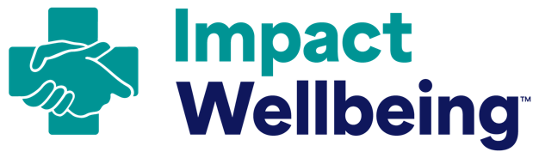
Communication Plan Outline

How to use this outline:
- Use the following outline as a starting point to facilitate a conversation between your Professional Wellbeing Team and the Communication Team at your hospital and create a communication plan.
  - As the Executive Sponsor, work with the Communication Department or Team at your hospital or a communication professional on your Professional Wellbeing Team to fill in the notes section and save this as a reference point as the full team moves through the following Actions.
- Consider diversity in roles and demographics when developing your plan. Products and messages may need to be tailored to best reach different members of your workforce.
- Continually use this outline as an internal reference point to ensure that you are keeping your workforce up to date as you progress.
Section | Guiding Question | Tip
Background | What do you know about the current state of professional wellbeing at your hospital? | Use the Hospital Review Worksheet from  Action 1 to find a summary of your organization’s current efforts.
Notes:
Goals | What effect do you want your communication efforts to have? | Aim to make these “SMART” goals, meaning Specific, Measurable, Achievable, Relevant, and Time-Bound.
Notes:
Audience(s) | Who do you want to reach and why? | Ensure you aim to reach licensed healthcare workers as a starting point. As your communication and wellbeing work continues, be sure to reach other staff within the hospital including patient care technicians, facilities, and custodial staff, clerks, and others.
Notes:
Messages | What do you want people to know? | Keep your messages consistent, focused on a specific topic, and aligned with your goals. Start with messages for licensed healthcare workers and consider how to tailor or adjust your messages based on other hospital staff audiences.
Notes:
Channels | How are you going to get your message out to your audience? | Consider using a combination of in-person events, digital communication, and print materials to reach healthcare workers at your hospital, including opportunities for two-way communication.
Notes:
Materials | What products will support your  communication efforts? | Use a variety of formats and channels (e.g., posters/signs, email listservs, etc.) to increase the chances of your staff seeing/hearing your updates. Find shareable materials on the Impact Wellbeing website to get started.
Notes:
Timing | How often will you communicate with your workforce? | Plan your communication around milestones (e.g., introducing the Professional Wellbeing Team, launching credentialing updates). Consider timing these announcements with existing events like Grand Rounds or scheduled department meetings
Notes:
Evaluation | How will you know that your messages reached your audience? | Ask managers and staff if they remember hearing/seeing updates about your hospital’s wellbeing work (such as updates to credentialing application questions from Action 3). You could also use emails or in-person meetings to collect this feedback.
Notes:

Centers for Disease Control and Prevention [2018]. Health communication playbook: Resources to help you create effective materials. Atlanta, GA: Centers for Disease Control and Prevention.

