Name:

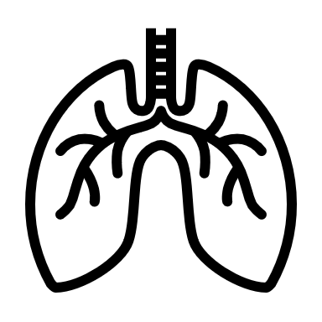 | Exploring Polio  Student Data Collection Sheet

Think About It! Write your answers below:
Understanding Polio | - What microbe causes polio?
 | - How is polio spread in a community?
 | - Why do some communities lack access to clean water and sewage sanitation?

Polio and  CDC | - What symptom is required for a person to be considered to have polio?
 | - What types of discrimination do people with physical disabilities experience?
 | - What are the disadvantages of iron lung treatment?
In this step, you share your information. Sharing the information you collect is key. Click the links below to share:
https://observer.globe.gov/do-globe-observer/mosquito-habitats
http://www.citizenscience.us/imp/collectionform.php

Call to  Action | - What are the dangers associated with polio?
 | - Why is it important for everyone to understand the dangers of polio?
 | - How can your efforts support the efforts of CDC?

Conduct a Breathing Demonstration: Observations
What happens to the pressure in the bottle when you pull down on the balloon?

What happens to the size of the lungs when you pull down on the balloon?

What happens to the pressure in the bottle when you release the balloon?

What happens to the size of the lungs when you release the balloon?

If the phrenic nerve is damaged due to polio, thus paralyzing your diaphragm, how would this affect your breathing?

Conduct a Breathing Demonstration: Write Your Script

Reflections
Now that you have built a model and shared your findings, think about what you learned about polio. Answer the questions below.
- What is the poliovirus and how is it transmitted?

- What are the symptoms and consequences of polio?

- What are some challenges communities might experience in accessing proper sanitation and vaccination?

- Health equity is achieved when every person has the opportunity to attain his or her full health potential and no one is disadvantaged from achieving this potential because of social position or other socially determined circumstances. What are some of the health equity issues surrounding polio?

- Before he was president, Franklin D. Roosevelt was diagnosed with polio in 1921 at the age of 39, resulting in permanent paralysis of his legs. He founded the National Foundation for Infantile Paralysis in 1938 to study the disease. How do you think this changed history?

- Why is it important to raise awareness about global public health?

