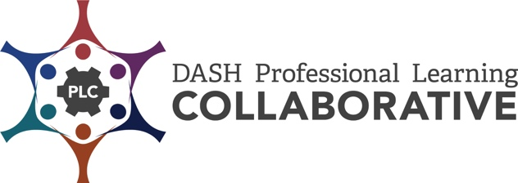

CDC Professional Development Practices Inventory
The CDC Professional Development Practices (PDPs) are a series of steps based on research and best practices. When effectively applied, they increase active learner engagement and provide optimal conditions for the transfer of learning and implementation of the knowledge and skills in the work setting. These practices provide a process to achieve sustainability over time.
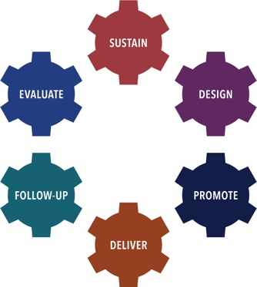 | There are six PD Practices used as the framework for this inventory:  - Sustain a PD Infrastructure,  - Design PD Offerings,  - Promote PD Offerings,  - Deliver PD,  - Provide Follow-Up Support, and  - Evaluate PD Processes.

The CDC Professional Development (PD) Practices Inventory was developed to assist DASH funded partners in identifying best practices and processes for establishing a comprehensive professional development (PD) program. The Inventory is designed as a tool for an individual and/or team to assess strengths, areas of growth, priorities, and next steps in the implementation of the CDC PD Practices.

Directions:
- Individually, or with other colleagues responsible for providing effective professional development, review all or selected CDC PD Practice Inventory items.
- Decide if each CDC PD Practice item is “not yet in place”, “partially in place”, “mostly in place”, or “fully in place”.
- Determine your strengths and areas of growth for each CDC PD Practice reviewed.
- Identify your priorities and next steps to implement each CDC PD Practice reviewed.

DASH Definitions:

Professional Development (PD) is an intentionally designed, systematic process used to strengthen the knowledge, skills, and attitudes of a particular workforce. The goal of PD, in the context of Centers for Disease Control and Prevention’s (CDC’s) Division of Adolescent and School Health (DASH) priorities, is to help improve the health, education, and well-being of youth. Professional development contributes to this goal by enhancing the knowledge, skills, and attitudes of health and education professionals so that they can more effectively implement strategies that positively impact young people. The strategies may support classroom management, effective teaching, and the DASH strategies, such as sexual health education, sexual health services, and safe and supportive environments.

- Professional Development Event is a set of skill-building processes and activities designed to assist targeted groups of participants in mastering specific learning objectives. Such events are delivered in an adequate time span (at least three hours) and may include curriculum and other training, workshops, and online or distance learning courses.

- Professional Development Offering is events, information and presentation sessions, and technical assistance.

- Technical Assistance is targeted support provided to an individual or group of individuals with the intent to increase knowledge and skills to strengthen an organization’s capacity to achieve PS18-1807 NOFO goals. Support may be provided through professional development events, technical assistance, the provision of guidance and resource materials, or referrals to other agencies or organizations.

Evaluate PD Processes  Collect usable data throughout the PD process. Use these data to inform your PD plan and report your successes and lessons learned. The Evaluate practice systematically monitors and evaluates your professional development offerings by collecting data and using it to improve future efforts. | 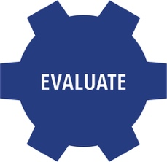

Processes to Evaluate PD Processes | Not yet in place | Partially in Place | Mostly in Place | Fully in Place
Assess PD needs of the target audience, as applicable (see Design).
Develop a plan, per DASH’s PD Evaluation Toolkit guidelines, to measure the PD offering learning objectives. This may include collecting information about the transfer of learning after the PD offering, if applicable and resources allow.
Identify or develop instruments to collect evaluation data from multiple sources.
Collect evaluation data related to promotion, PD offerings, TA delivery, and follow-up support (see Promote, Deliver and Follow-Up Support).
Determine whether PD offering goals and objectives were achieved.
Use a data entry protocol.
Maintain evaluation data in an organized data management system.
Report evaluation results to stakeholders to facilitate use of the findings.

Evaluate PD Processes
Strengths: | Areas of Growth:

Evaluate PD Processes – Priorities / Next Steps | By When | Person Responsible

Modified by the ICF-CDC DASH Professional Learning Collaborative (PLC), 2019. Adapted from CDC DASH Professional Development Practices - Inventory | ETR-CDC DASH Professional Learning Collaborative (PLC), 2015. Original version created by RMC Health-CDC DASH Professional Development Partnership (PDP), 2009

