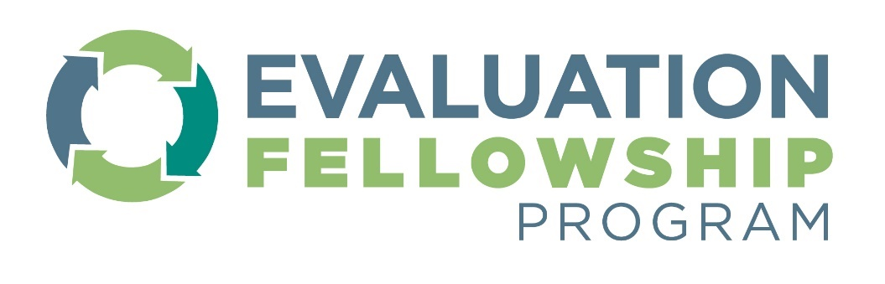

Class of 2024 Application Cheat Sheet for FELLOWS
The purpose of this document is to help potential applicants to the CDC Evaluation Fellowship Program prepare responses to their applications prior to entering them into CDC’s Enterprise Fellowship Management System (EFMS). More information on the fellowship, eligibility criteria, deadlines, and the application portal can be found here: CDC Evaluation Fellowship Program | CDC
Below are main sections of the application and the kind of information applicants need to provide. This is not a user guide to navigating EFMS. For any discrepancies between this cheat sheet and EFMS, please defer to the EFMS version. For questions, please email evaluationfellowship@cdc.gov
Applicant profile page
- Name, address, and contact information
- An emergency contact
Application section: Citizenship
The CDC Evaluation Fellowship Program is accepting applications from only U.S. citizens and permanent residents with an active green card. The green card must be valid for at least two more years from the start of the fellowship (mid-Aug) for the duration of the Fellowship.

Field or question | Type of response
Country of Citizenship: | Multiple Choice
Are you a U.S. permanent resident? | Yes/No

Application Section: Document uploads
- Resume/ cv
- Official transcripts of qualifying degree(s) (graduate degrees only)
- A copy of your green card with expiration date past end of two-year Fellowship (if applicable)
Application Section: Education
Field or question | Response type
What is the highest degree you will have attained by the start of the program? | Multiple Choice
For each pertinent graduate degree
Has your degree been conferred? (i.e., Have you received your degree) | Yes/No
Degree Conferral Date: | Date
Major 1: | Short Text
Major Classification: | Multiple choice
Country: | Multiple choice
State/Province | Multiple choice
College/University: | Multiple choice

Application Section: Evaluation experience and personal statements
Field or question | Response type
How would you assess your current level of knowledge/skill for program evaluation? | Multiple choice
How many years of experience do you have in program evaluation? | Number
List any special skills, research topics/experience, or other areas of expertise that you have. | LongText [<250 words]
Briefly provide some information on your formal training (classroom or otherwise) where all or part of the focus was on program evaluation approaches, methods, techniques, etc. | LongText [<250 words]
Describe the two most important skills you want to develop or improve during this program | LongText [<250 words]
Please describe what qualifies you for the CDC Evaluation Fellowship Program | LongText [<250 words]
Describe how this fellowship will help you achieve your goals | LongText [<250 words]

Application Section: Work & Volunteer Experience
Field or question | Response type
Briefly describe up to three program evaluation projects you worked on. Please include your role in the project, evaluation approach and methods used, and outcomes or impact of the project. | LongText X 3 options [<250 words each]
Please describe your lived experience and/or experience working in a setting (e.g., work environment or situation), collaboration, or context where there is diverse representation in perspectives, background, and/or culture. Please describe how the environment, situation, or context is diverse and your approach to bringing different people, perspectives, and background together. Please describe how you may have considered for diversity, equity, inclusion, accessibility, and belonging (DEIAB). | LongText [<250 words]
Have you participated in any CDC fellowship programs? | Yes/No
(if “Yes” to previous question). Please select all CDC fellowships that you have participated in: | Multiple Selection

Application section: Applicant survey
Field or question | Response type
Which of the following most influenced you to apply to this fellowship? (select up to 3) | Multiple Selection
What is your ethnicity? (optional) | Multiple Choice
What is your race? (select all that apply) (optional) | Multiple Selection

Recommendation request
Candidates are required to provide and request two (2) confidential recommendations through the EFMS portal. Recommenders will receive a personalized email request to complete the recommendation within the EFMS system. Here is the information that each applicant needs to be prepared to provide for each recommender:
Field or question | Response type
Recommender's Name: | Open text response
Organization: | Open text response
Job Title: | Open text response
Phone: | Open text response
Email: | Open text response
Relationship to you: | Open text response
Note to the recommender: | Open text response
Letter of Recommendation Waiver Agreement: "In order to be considered for the fellowship program, I agree to waive my right to view any recommendations submitted for me." | Affirmation check box

