Annual AU Option Data Validation
Facilities should use the following guidance on an annual basis or in the event of extreme high or low SAAR values. The NHSN AU Option Team developed these questions to focus validation efforts on key AU Option protocol definitions and common data errors. We expect facilities to use this document internally. Facilities do not need to share the results with NHSN.
Facilities in the AU implementation process or that have recently switched EHR systems should use the separate, more detailed AU Option Implementation Data Validation Protocol. Facilities interested in validating AR Option data can refer to the AR Option Data Validation Protocol.
Please email questions to the NHSN Helpdesk: NHSN@cdc.gov.
Validation Checklist
 | Complete | Page
NHSN Location Mapping | ☐ | 2
Review for changes in patient mix | ☐ | 2
Add brand new locations | ☐ | 2
Inactivate permanently closed locations | ☐ | 2
Monthly Reporting Plans | ☐ | 3
Check for inactive locations | ☐ | 3
Add brand new locations | ☐ | 3
Review calendar year for completeness | ☐ | 3
NHSN AU Option Users | ☐ | 4
Confirm two active AU users | ☐ | 4
Deactivate former AU users | ☐ | 4
AU Option Data | ☐ | 4
Review location specific SAARs | ☐ | 4
Examine drug specific trends | ☐ | 7
Use the data quality line list | ☐ | 9
Perform a spot check of the data | ☐ | 9
Check and compare denominators | ☐ | 11
Appendix: Links to referenced documents | ☐ | 14

NHSN Location Mapping
It’s important to keep your facility’s NHSN Locations up to date so that your data can be appropriately risk adjusted in the SAAR calculations. You should discuss locations with your facility’s Infection Prevention department since your facility should use the exact same NHSN locations for reporting all NHSN data, which includes both HAI and AU. Details on the location mapping process as well as the detailed descriptions of all CDC Location Types can be found in the NHSN Location Protocol. Facilities can find additional details within the NHSN location FAQs.
Users with Administrative rights within the NHSN facility can see the NHSN locations after logging into NHSN by clicking “Facility” then “Locations” on the left-hand navigation bar. On the Locations screen, click “Find” to generate a table of all active locations within your NHSN facility. To work on the locations outside of NHSN from an excel file, click “Export Location List” on the Locations screen.
After reviewing the current list of active locations within your NHSN facility, address the following questions:
- Of the active locations, are there any changes in patient mix (for example, a location that was previously a Medical Ward which should now be classified as a Medical/Surgical Ward)?
  - If there are changes that need to occur, work with the IP to:
    - Add the new location(s) with a unique “Your Code” value and the appropriate CDC Location Description.
    - Once you and the IP have entered/uploaded all historical NHSN data, set the old location(s) to inactive.
    - Update your monthly reporting plan to remove the old inactive(s) location and add the new location(s) for each month the new location type was active.
    - Make/confirm the change in your vendor system. Be sure you enter the exact “Your Code” and CDC Location Description values used by the new NHSN location(s) added above. The vendor system uses those values in the CDA file generation and upload process.

- Are there any new locations (for example, new construction) that your facility needs to add to NHSN?
  - If there are any new locations, work with the IP to:
    - Add the new location(s) with a unique “Your Code” value and the appropriate CDC Location Description.
    - Update your monthly reporting plan to add the new location(s).
    - Make/confirm the change in your vendor system. Be sure you enter the exact “Your Code” and CDC Location Description values used by the new NHSN location(s) added above. The vendor system uses those values in the CDA file generation and upload process.

- Has your facility permanently closed any locations (for example, no longer have an inpatient rehabilitation location at the facility)?
  - If your facility has permanently closed any locations, work with the IP to:
    - Set the location(s) to inactive status within the NHSN Location Manager.
    - Once you and the IP have entered/uploaded all historical NHSN data, set the old location(s) to inactive.
    - Update your monthly reporting plan to remove the old inactive location(s) for months in which it was closed.
    - Make/confirm the appropriate change in your vendor system.

Monthly Reporting Plans
Monthly reporting plans outline which locations the facility plans to submit data for each month. Facilities cannot upload AU Option data off-plan. This means if the facility does not include the given location in the monthly reporting plan for that month, the AU CDA file will fail to upload. Additionally, NHSN generates alerts for missing data based on the selections in the monthly reporting plan. Facilities can complete monthly reporting plans at the beginning of the year for the entire calendar year or prior to monthly upload of AU data. NHSN uses the exact same monthly reporting plan for both HAI and AU data, so it is important to make changes only to the Antimicrobial Use & Resistance Module section of the plan. If your IP normally completes the reporting plan for the AU Option, please work with them to complete the below review.
Users with specific rights within the NHSN facility can see the monthly reporting plans after logging into NHSN by clicking “Reporting Plan” then “Add” or “Find” on the left-hand navigation bar. Select the Month and Year for the specific reporting plan you’d like to add or find. To edit an existing plan, scroll down to the bottom of the reporting plan screen and click “Edit”.
- Are all locations in the AU section of the reporting plan for this current calendar year still active? Inactive locations will have “[INACTIVE]” in the location name (see below screenshot):
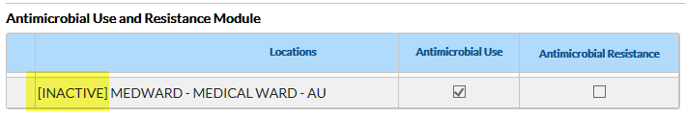
  - Remove inactive locations from the AU reporting plan by clicking “Edit” at the bottom of the reporting plan screen, then click the trash can icon next to the inactive location. Click “Save” to save the updated reporting plan. Complete these steps for additional months as necessary.

- Are all new NHSN locations included in the AU reporting plan? This includes new locations due to both a change in patient mix and new construction. Note: The reporting should only include locations where the vendor software can accurately electronically capture both the numerator and denominator.
  - Add new locations to the AU reporting plan by clicking “Edit”, then clicking “Add Row”. Make sure to check the “Antimicrobial Use” box(s), then click “Save” to save the updated reporting plan.

- If your facility completes reporting plans for the entire calendar year at one time, is the AU section of the reporting plan complete for all months of the calendar year?
  - If not, add the appropriate locations to the reporting plan by clicking “Edit”, then clicking “Copy from Previous Month” within the AU section of plan. Then click “Save” to save the updated plan.

NHSN AU Option Users
NHSN recommends having at least two active AU Option users within each NHSN facility to ensure continuous reporting in the event of extended illness, vacation, or termination of employment. The NHSN Facility Administrator can assign AU Users a variety of user rights depending on the specific duties that the user will be fulfilling for AU reporting. NHSN developed a document outlining three levels of AUR Module user rights for guidance. Email questions about NHSN User Rights to the NHSN Helpdesk: NHSN@cdc.gov.
Users with Administrative rights within the NHSN facility can see the list of active NHSN users by clicking “Users” then “Find” on the left-hand navigation bar. Information on managing NHSN users can be found in the December 2014 NHSN Newsletter.
- Are there currently at least two active AU Option users within your NHSN facility?
  - Users with Administrative rights can add new users by clicking “Users” then “Add” on the left-hand navigation bar. Complete the fields on the Add User screen and click “Save”. Then assign the appropriate level of user rights and click “Save”.
  - As of December 2020, AU Option users can be designated as the “Antimicrobial Use Option Contact” on the Add/Edit User screen. You can assign more than one facility user as a contact for the AU Option and a single user can be the contact for both the AU and AR Options. The NHSN AUR Team will use this information to target notifications for AUR related content like AU and AR quarterly users calls, updates regarding AUR resources, and data quality related outreach.

- Are there AU Option users that are no longer at the facility or no longer responsible for the AU Option data?
  - Users with Administrative rights can deactivate users following the instructions starting on page 14 of the December 2014 NHSN Newsletter (see above link).

AU Option Data
The following steps assume that the facility has been continuously submitting AU data into NHSN. Facilities in the AU implementation process or that have recently switched EHR systems should use the separate, more detailed AU Option Implementation Validation Protocol. We recommend that you use the most recent three years of AU data within NHSN to review these questions to spot trends in the data. You can answer all questions by running reports and/or reviewing data uploaded into NHSN. No external review of data is necessary.
Prior to reviewing your AU data, remember to generate new data sets. Be sure to include relevant years of data in your data sets following the instructions on data set generation.
To find the AU Option analysis reports, click “Analysis” then “Reports” on the left-hand navigation bar. On the Analysis Reports page, click the “Antimicrobial Use and Resistance Module” folder then click the “Antimicrobial Use Data” folder. For guidance on how to run and interpret the available AU Option reports, refer to the AU Option Analysis Training and the AU Option Analysis Quick Reference Guides on the AUR Module webpage.

Review Location Specific SAARs
Note: NHSN applies facility-level risk-adjustments in SAAR models using NHSN Patient Safety Component Annual Hospital Survey data where NHSN matches survey year to AU year. However, because facilities complete surveys annually, while they report AU data monthly, there is a period of 12+ months where NHSN risk adjusts SAARs using a previous year’s survey data. Some facilities may notice shifts in SAAR values once current survey data replace old survey data for risk-adjustment in SAAR calculations.

Additionally, the 2017 adult and pediatric baseline SAARs and the 2018 neonatal baseline SAARs rely heavily on survey level variables for appropriate risk adjustment. Consider also reviewing your facility’s Annual Hospital Survey to better understand your facility’s risk adjustment. More details on how the Annual Hospital Survey values affect the SAARs can be found in the Guide to the SAAR.

Within the Antimicrobial Use Data analysis folder, select the report titled “SAAR Report – All Adult and Ped SAARs by Location”. Click “Run Report” to run the default report displayed by month. The default report shows one table per SAAR category. Within each table, you’ll see rows for each applicable SAAR location (for example, adult and pediatric medical, surgical, and medical/surgical ICUs and wards) displayed by month. To view neonatal SAARs, select the report titled “SAAR Report – All Neonatal SAARs by Location”, then click “Run Report.”

- Do your location specific SAARs seem to follow expected trends over time? (specifically, SAARs are not drastically changing from month to month [for example: SAAR of 0.8 to SAAR of 2.3] for a given location)
- Are there any outliers for a specific location or a specific month? Refer to the 2019 AU Data Report Tables to determine if your SAARs are in the top or bottom percentiles of reported data.
  - For outlier SAARs, review antimicrobial days and days present for outlier values.

Using Bar Charts to Review Distributions
For SAARs under review (excluding SAAR for All Antimicrobials), use a Bar Chart report to see distribution of drugs in that specific SAAR category (for the list of drugs included in each SAAR category, review the Appendix E of the AUR Module Protocol).
- Within the Antimicrobial Use Data analysis folder, select the report titled “Bar Chart – All Data – Selected Agent Distribution by Month”. Click “Modify Report” to make the necessary modifications.
- Check the box “Show descriptive variable names” at the top left of the modification screen.
- On the Time Period tab, select “Summary Year/Month” as the Date Variable and a 12-month time period for review. (The Bar Charts display best with 12 bars or less.)
- On the Filters tab, you’ll notice that the default filter shows the antimicrobials for the 2017 baseline broad spectrum antibacterial agents predominantly used for community-acquired infections SAAR. If running the bar chart for another SAAR category, remove the default antimicrobials and add the appropriate antimicrobials. For example, the screenshot below shows the default for the 2017 baseline antibacterial agents posing the highest risk for CDI SAAR:
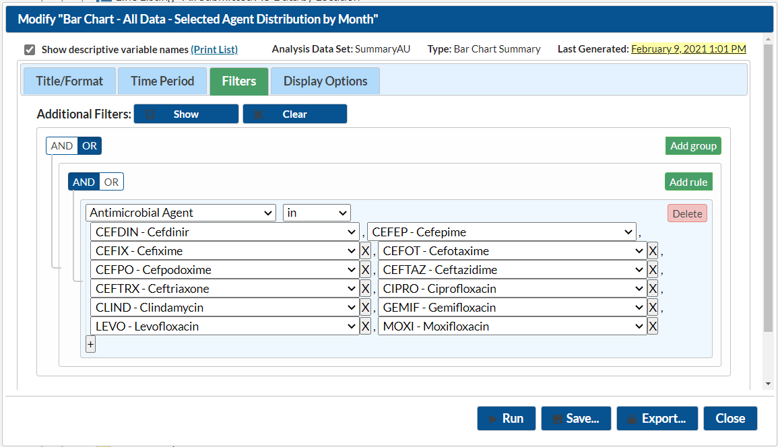
- On the Display Options tab, select the options as shown in the below screenshot:
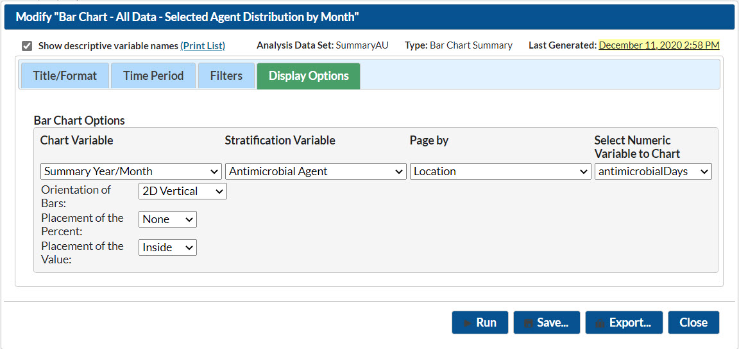
- Click “Run” to generate the bar charts. Note: Drugs that you included in the filter but are not showing on bar chart equal 0 antimicrobial days for that month.

- Are there any drugs that are lower or higher than anticipated for a given month/location?
- Are there any drugs that have drastic changes from month to month?

Using Line Lists to Review Outlier Values
For any specific drugs that have unexpected or abnormal values, run a line list to pinpoint the exact antimicrobial day values reported. Within the Antimicrobial Use Data analysis folder, select the report titled “Line List – All Submitted AU Data by Location”. Click “Modify Report” to make the necessary modifications.
- Check the box “Show descriptive variable names” at the top left of the modification screen.
- On the Filters tab, add a rule and select “Antimicrobial Agent” as the variable. To view more than one antimicrobial in the line list use “in” as the operator. To see only one antimicrobial in the line list, use “equal” as the operator.
- Click “Run” to generate the line list. The report will show one table per location. Within that table, NHSN lists each drug for all months of data reported.

- Review the data to determine which values need further investigation within the eMAR/BCMA system and/or with your vendor.

Examine Drug Specific Trends
Remember that drug shortages may affect drug-specific trends. Pick the three antibacterials (for example, ceftriaxone, piperacillin/tazobactam, vancomycin), one antifungal (for example, fluconazole), and one anti-influenza (for example, oseltamivir) that are most used within your facility to review.

You can review trends over time within NHSN either by running rate tables or bar charts. Keep in mind that while bar charts are a more visual way to look at the data, NHSN limits them to show only 12 bars per chart. The instructions for both methods are below. Pick the one method of your choice.

Rate Tables:
- Within the Antimicrobial Use Data analysis folder, select the report titled “Rate Table – Selected Drugs – by Location – All Months”. Click “Modify Report”.
- Check box for “Show descriptive variable names” at the top left of the modification screen.
- On the Filters tab, select “Antimicrobial Agent~Description” as the variable. We recommend viewing one drug at a time so use “equal” as the operator and select your antimicrobial of interest.
- Click “Run” to generate the rate table. The report will show one table per location. Within that table, NHSN generates a rate per month of data submitted.

Skip down to the questions

Bar Charts:
- Within the Antimicrobial Use Data analysis folder, select the report titled “Bar Chart – All AU Data by Antibacterial Class and Location”. Click “Modify Report”.
- Check box for “Show descriptive variable names” at the top left of the modification screen.
- On the Time Period tab, select “Summary Year/Month” as the Date Variable and a 12-month time period for review. (The Bar Charts display best with 12 bars or less.) Enter the beginning and ending dates (for example: 07/2019 - 07/2020).
- On the Filters tab, delete the existing filter for antibacterial class. Click “Add rule” and select “Antimicrobial Agent” as the variable and “in” as the operator if viewing one drug and “equal” as the operator if viewing multiple drugs. Select the specific drugs you’d like to view. (see below example)
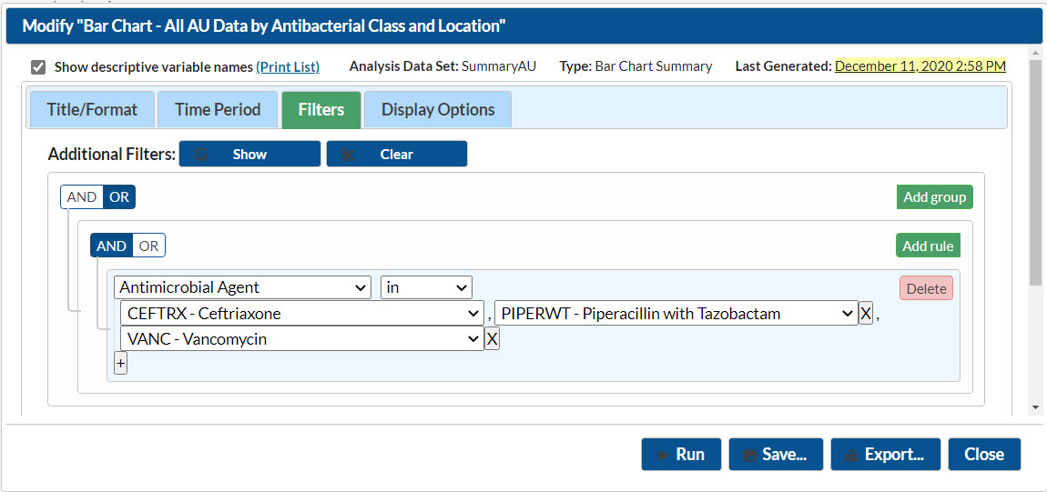
- On the Display Options tab, select the options as shown in the below screenshot:
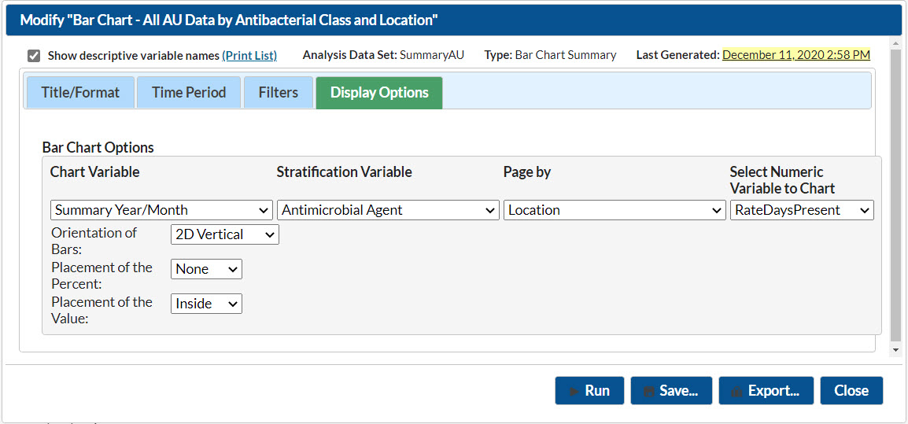
- Click “Run” to generate the bar charts. Note: Drugs that you included in the filter but are not showing on bar chart equal 0 antimicrobial days for that month.

- Are there any drug-specific rates that are lower or higher than anticipated for a given month/location?
  - If so, are these changes a result of the antimicrobial day counts, the days present counts or both?
- Are there any drug-specific rates that have drastic changes from month to month?
  - If so, are these changes a result of the antimicrobial day counts, the days present counts or both?
For drugs that are lower or higher than anticipated for a given month/location, run a line list for that drug to look for trends over time. You can find instructions for running a drug-specific line list above.

Use the Data Quality Line List
The AU Option Data Quality Line List provides facilities with a quick way to assess four common data quality issues.
- Zero or missing antimicrobial days
- Antimicrobial days reported with patients were not present
- Antimicrobial days ≥ Days present
- Sum of routes < Total Antimicrobial days
Run the Data Quality Line List within NHSN to check if these common issues are present in your data. Within the document, you’ll also find guidance for interpreting your output and next steps for how to address the data quality issue(s).

Perform a Spot Check of the Data
You can use line lists to spot check specific items such as the routes of administration and drug-specific trends or general items such as numerator and denominator aggregations. For each item below, use the report titled “Line List – All Submitted AU Data by Location”. Click “Modify Report” to make the necessary modifications.
- Check box for “Show descriptive variable names” at the top left of the modification screen.
- On the Filters tab, make the modifications as outlined in each scenario below. Delete the existing filter for location “not equal” to FacWideIN. For filters that require more than one variable, make sure to click “Add Rule” for each new filter you apply.
- On the Sort tab, make the modifications as outlined in each scenario below (if applicable).
- After you’ve selected all filters, click “Run” to generate the line list.

Routes of Administration
- Intramuscular (IM) administrations
  - Look for IM administrations in ED location (if applicable). Is the vendor system appropriately capturing/reporting IM ED administrations (for example, ceftriaxone)?
    - Filters: CDC Location “equal” to Emergency Department; Route:IM “greater” than 0
    - Sort: Antimicrobial Agent~Description or Summary Year/Month
  - Confirm IM use is rarely occurring in inpatient locations.
    - Filters: CDC Location “not in” Emergency Department and 24-hour Observation Area; Route:IM “greater” than 0
    - Sort: Antimicrobial Agent~Description or Summary Year/Month

- Intravenous (IV) administrations
  - If using continuous or extended infusion (for example, of piperacillin-tazobactam), confirm usage in those specific locations.
    - Filter: Location “in” (select specific locations with continuous or extended infusion); Route:IV “greater” than 0
    - Sort: Antimicrobial Agent~Description or Summary Year/Month

- Digestive tract administrations
  - If using IV formulation of vancomycin for oral or rectal administrations, confirm usage in those specific locations.
    - Filter: Location “in” (select oral or rectal vancomycin administration locations); Route:Digestive “greater” than 0; Antimicrobial Agent~Description “equal” to vancomycin
    - Sort: Antimicrobial Agent~Description or Summary Year/Month

- Respiratory tract administrations
  - If using inhaled drugs (for example, aztreonam, tobramycin, amikacin, gentamicin, zanamivir), confirm usage in those specific locations.
    - Filter: Location “in” (select inhaled administration locations); Route:Respiratory “greater” than 0
    - Sort: Antimicrobial Agent~Description or Summary Year/Month

Drug-Specific Trends
- Confirm that there are higher antimicrobial days for commonly used drugs within your facility (for example, ceftriaxone, piperacillin/tazobactam, vancomycin).
  - Filter: Antimicrobial Agent~Description “in” (select commonly used drugs in individual drop-down boxes)
- Confirm that there are lower antimicrobial days for less commonly used drugs within your facility (for example, oral cephalosporins, nafcillin).
  - Filter: Antimicrobial Agent~Description “in” (select less commonly used drugs)
- Confirm higher usage of beta-lactams such as ampicillin and penicillin G in mother/baby locations (for example, Labor & Delivery Ward, Postpartum Ward, Labor/Delivery/Recovery/Postpartum Suite [LDRP], and/or Nursery).
  - Filter: Antimicrobial Agent~Description “in” ampicillin and penicillin G; Location “in” (select mother/baby locations)
- Confirm the vendor system is correctly capturing single and combination drugs such as amoxicillin and amoxicillin/clavulanate, ampicillin and ampicillin/sulbactam, ceftazidime and ceftazidime/avibactam, and meropenem and meropenem/vaborbactam. For example, the vendor system is not mapping and aggregating ceftazidime/avibactam to ceftazidime.
  - Filter: Antimicrobial Agent~Description “in” amoxicillin, amoxicillin/clavulanate, ampicillin, ampicillin/sulbactam, ceftazidime, ceftazidime/avibactam, meropenem, and meropenem/vaborbactam

FacWideIN versus Sum of Locations
Note: For location specific reporting, the vendor system should count administrations in each location where the patient was physically located at the time of administration. However, when calculating FacWideIN, the patient can only attribute one total antimicrobial day per drug, regardless of how many different patient care locations they received the drug that calendar day. For example, the location specific piperacillin/tazobactam antimicrobial days may add up to be higher than the FacWideIN piperacillin/tazobactam antimicrobial days because piperacillin/tazobactam can be administered more than once daily. Therefore, if a patient received piperacillin/tazobactam once in the medical ward in the morning then was transferred and received the remaining doses in the medical ICU, that patient would attribute 1 total piperacillin/tazobactam antimicrobial day to both the medical ward and the medical ICU but could still only attribute 1 total piperacillin/tazobactam for the FacWideIN count.
- For drugs administered more than once daily (for example, piperacillin/tazobactam, cefazolin, meropenem, imipenem), confirm that the sum of the location-specific antimicrobial days for a given drug is higher than the FacWideIN antimicrobial days for that drug for same month.
  - Filter: Antimicrobial Agent~Description “in” (select drugs administered more than once daily)
  - Sort: Antimicrobial Agent~Description, Location
  - Display: Summary Year/Month
- For drugs administered once daily (for example, azithromycin, levofloxacin, moxifloxacin), confirm that the sum of the location-specific antimicrobial days for a given drug is equal to the FacWideIN antimicrobial days for that drug for the same month.
  - Filter: Antimicrobial Agent~Description “in” (select drugs administered once daily)
  - Sort: Antimicrobial Agent~Description, Location
  - Display: Summary Year/Month

Zero versus N/A Usage
Note: According to the AU Option Protocol “Not applicable (N/A)” is used when antimicrobial can’t be electronically captured from eMAR/BCMA. “N/A” will display in the NHSN AU report as “.”. Facilities should use “Zero” when they had no patients administered the drug and/or route during the given month. “Zero” will display in the NHSN AU report as “0”.
- Are there any drugs that would require reporting N/A because the vendor system cannot accurately electronically capture them?
  - Filter: Antimicrobial Agent~Description “in” (insert drugs not captured in eMAR/BCMA)

- Are there any drugs reported as “Not applicable (N/A)” that can be electronically captured from eMAR/BCMA?
  - Filter: Antimicrobial Days “less” “0”

Check and Compare Denominators
The days present denominator is an important part of the SAAR models and therefore you should also validate it. For the items below, use the report titled “Line List – All Submitted AU Data by Location”. Click “Modify Report” to make the necessary modifications.
- Check the box “Show descriptive variable names” at the top left of the modification screen.
- On the Filters tab, make the modifications as outlined in each scenario below. For filters that require more than one variable, make sure to click “Add Rule” for each filter you apply. Because the report lists the same denominator for all drugs for a given location/month, include a filter to view only one drug.
- On the Sort tab, make the modifications as outlined in each scenario below.
- After you’ve selected all filters, click “Run” to generate the line list.

Reviewing AU Days Present
- Examine the days present for trends within specific locations. Double check steep increases or drop offs to confirm validity. Double check locations reporting zero days present for a given month to confirm that the location was in fact closed or did not house patients during that month.
  - Filter: Antimicrobial Agent~Description “equal” to vancomycin
- For a given month, confirm that the sum of location-specific days present are higher than the FacWideIN days present count for same month.
  - Filter: Antimicrobial Agent~Description “equal” to vancomycin
  - Display: Summary Year/Month

Comparing AU, AR and HAI Denominators
If submitting data into other NHSN Modules (specifically, Device-associated, MDRO/CDI), you can compare those denominator data to the AU Option denominator data with help of NHSN Facility Administrator or IP staff. Facilities participating in CMS reporting will report:
- Location-specific HAI patient days within Device-associated summary records for all adult, pediatric, and neonatal ICU locations along with adult and pediatric medical, surgical, and medical/surgical ward locations
- FacWideIN patient days and admissions within the monthly MDRO/CDI summary record
- ED and/or 24-hour observation location encounters within the monthly MDRO/CDI summary record
Please ask your NHSN Facility Administrator or IP staff to provide these numbers. Here are a few key definitions:
Days Present in AU Option: The system should count a patient in a location if they are there at any time during the calendar day. The system should not count a patient more than once in a specific location during a single calendar day (specifically, a patient transferred out and back into the location is still only counted by the vendor system as 1-day present in that location).
Patient Days in other NHSN Modules: The system should count a patient in a location only if they are in that location at the time of the once daily census count (generally done around midnight).
AU & AR Admission: The system should count a patient as an admission if the facility admits the patient to an inpatient location within the facility starting on the first day of each calendar month. A patient is counted as an admission when they arrive in an NHSN designated inpatient location regardless of patient status (for example, inpatient, observation). A patient admitted to an inpatient unit would be counted as an admission even if they were discharged that same calendar day.
MDRO Admission: A patient is counted as an admission when they arrive in an NHSN designated inpatient location regardless of patient status (for example, inpatient, observation). The system should count a patient as an admission if the admission date and discharge dates are different calendar days.
MDRO Outpatient Encounter: The system should count a patient if they visit the outpatient location at any time during the calendar day. If a patient’s visit extends into another calendar day, the patient is still only attributed 1 encounter per visit.

Location-Specific AU Days Present versus HAI Patient Days
Populate the table below using data from the AU and HAI submissions and calculate the percent difference. The HAI patient days will come from the NHSN Device-associated summary records used for CLABSI/CAUTI reporting. We recommend checking at least two ICU locations, two ward locations, and one NICU location (if applicable).
Note: Based on internal NHSN analysis of AU and HAI data, on average, the AU days present are 24% higher than the HAI patient days for the same location. The full breakdown of median percent difference by location type can be found in the AU FAQs (Days Present section).
Percent Difference: $\frac{(AU Days Present-HAI Patient Days)}{AU Days Present} ×100$
Month/Year | Location Name | Total AU  Days Present | Total HAI Patient Days | Percent Difference
- If the percent difference is considerably higher than the median for the specific location type, consider discussing the denominator counts with your vendor. Check for double counting (for AU reporting, the vendor system should count a patient only once in a location per day).
- If AU Days Present are equal to the HAI patient days, check with your vendor as this should never happen.
- If AU Days Present are lower than the HAI patient days, check with your vendor to make sure the vendor system is including all patients in the AU location counts regardless of patient status (for example, observation, emergency).

FacWideIN AU Days Present versus FacWideIN MDRO Patient Days
Populate the table below using data from the AU and HAI submissions. The HAI FacWideIN patient days will come from the NHSN MDRO/CDI summary records used for LabID reporting. We recommend checking at least four months.
Note: Based on internal NHSN analysis of AU and HAI data, on average, for FacWideIN the AU days present are 24% higher than the HAI patient days.
Month/Year | Total AU Days Present for FacWideIN | Total Facility HAI Patient Days for FacWideIN MDRO/CDI | Percent Difference
- If the percent difference is considerably higher than average, is the vendor system including additional locations in the HAI patient day counts? For AU reporting, the vendor system should only include locations in FacWideIN where the system can accurately electronically capture both the numerator and denominator so some locations might be excluded from AU FacWideIN and included in HAI FacWideIN.

FacWideIN AU Admissions versus FacWideIN MDRO Admissions and AR Option Admissions
Populate the table below using data from the AU, HAI, and AR Option (if applicable) submissions. The HAI FacWideIN admissions will come from the NHSN MDRO/CDI summary records used for LabID reporting. The AR Option admissions will come from the AR Option denominator line list. We recommend checking at least four months.
Month/Year | Total AU Admissions for FacWideIN | Total Facility HAI Admissions for FacWideIN MDRO/CDI | Total AR Admissions for FacWideIN
- Are the admissions numbers reported within the AU Option and the MDRO/CDI Module roughly the same? The definitions are slightly different and the NHSN Team expects some small variation due to the different data sources used to collect these counts.

- Are the admissions numbers reported within the AU and AR Options roughly the same? These definitions are the same, but counts could vary if specific inpatient locations were included in one reporting option but not the other.

Emergency Department & 24-hour Observation area AU Days Present versus MDRO Outpatient Encounters
Populate the table below using data from the AU and HAI submissions. The HAI MDRO/CDI outpatient encounters will come from the NHSN MDRO/CDI summary records used for LabID reporting. We recommend checking at least two months for each location type (if applicable).
Note: Based on internal NHSN analyses of days present and encounters, on average the Emergency Department and 24-hour Observation AU days present are 14% higher than the HAI patient days for the same month/location.
Location | Month/Year | Total AU Days Present | Total HAI MDRO/CDI Encounters | Percent Difference
Emergency Department
Pediatric Emergency Department
24-hour Observation
- Is the percent difference similar to the national average of 14%?

Appendix: Links to Referenced Documents
Complete web addresses for references hyperlinked in this document in the order of appearance:
- NHSN AUR Module Protocol: https://www.cdc.gov/nhsn/pdfs/pscmanual/11pscaurcurrent.pdf
- AU Implementation Validation Protocol: https://www.cdc.gov/nhsn/pdfs/ps-analysis-resources/aur/AU-Option-Implementation-Data-Validation-P.pdf
- AR Option Data Validation Protocol: https://www.cdc.gov/nhsn/pdfs/ps-analysis-resources/aur/ar-validation-508.pdf
- NHSN Location Protocol: https://www.cdc.gov/nhsn/pdfs/pscmanual/15locationsdescriptions_current.pdf
- NHSN Location FAQs: https://www.cdc.gov/nhsn/faqs/faq-locations.html
- NHSN AU Option User Rights: https://www.cdc.gov/nhsn/pdfs/ps-analysis-resources/nhsn-au-user-rights.pdf
- December 2014 NHSN Newsletter: https://www.cdc.gov/nhsn/pdfs/newsletters/Newsletter-Dec2014.pdf
- NHSN Data Set Generation: https://www.cdc.gov/nhsn/pdfs/ps-analysis-resources/generatedatasets-psc-508.pdf
- NHSN AUR Module Webpage: https://www.cdc.gov/nhsn/psc/aur/index.html
- Guide to the SAAR: https://www.cdc.gov/nhsn/pdfs/ps-analysis-resources/aur/au-saar-guide-508.pdf
- SAAR Report – All SAARs by location: https://www.cdc.gov/nhsn/pdfs/ps-analysis-resources/aur/AU-QRG-SAARTables-Location.pdf
- 2019 AU Data Report tables: https://www.cdc.gov/nhsn/pdfs/datastat/2019-au-report-datatables.xlsx
- Bar Chart – Selected drugs: https://www.cdc.gov/nhsn/pdfs/ps-analysis-resources/aur/AU-QRG-BarChart-drugs-508.pdf
- AU Line List: https://www.cdc.gov/nhsn/pdfs/ps-analysis-resources/aur/AU-QRG-LineList.pdf
- AU Rate Table – Selected drugs by location: https://www.cdc.gov/nhsn/pdfs/ps-analysis-resources/aur/AU-QRG-RateTables-Location.pdf
- AU Bar Chart: https://www.cdc.gov/nhsn/pdfs/ps-analysis-resources/aur/AU-QRG-BarChart.pdf
- AU Data Quality Line List: https://www.cdc.gov/nhsn/pdfs/ps-analysis-resources/aur/au-dataquality-linelist-508.pdf
- AR Denominator Line List: https://www.cdc.gov/nhsn/pdfs/ps-analysis-resources/aur/ar-qrg-denom-linelist-508.pdf

