Name:

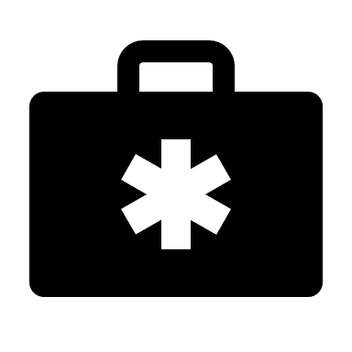 | Preparing for Disasters  Student Data Collection Sheet

Think About It! Write your answers below:
Understanding Disasters | - What kinds of natural or human-made disasters could happen in your area?
 | - Have you ever experienced a disaster? What helped you stay healthy and survive? If you haven’t experienced a disaster, what do you think would be helpful?
 | - What diseases could cause a widespread public health emergency?

Disaster Prevention and CDC | - What are two things you found surprising in this reading?
 | - Why do outbreaks of infectious diseases commonly occur after a natural disaster?
 | - What are two ways that CDC works with local and state health departments to help communities prepare for disaster?
In this step, you share your information. Sharing the information you collect is key. Click the links below to share:
https://observer.globe.gov/do-globe-observer/mosquito-habitats
http://www.citizenscience.us/imp/collectionform.php

Citizen Science | - If you woke up to a fire and could save only 3 things, what would you grab? Why?
 | - What do your 3 things tell you about your priorities in an emergency? How can you use this information to help you plan for future disasters?
 | - How do you respond in an emergency: cool and calm or panicked and anxious? How will you incorporate your typical reaction style into your disaster plan?

Develop a Disaster Plan
What kinds of emergencies will you be including in your plan? Why?
Write some discussion questions with family members on the following topics:
Emergency Alerts:

Shelter:

Evacuation:

Communication:

What special considerations do you need to make when gathering supplies and making plans for your household?

Make a Plan
Write down your detailed plan using the provided instructions. You can use the printable plans from https://www.ready.gov/plan to make it easy.

Build a Disaster Kit
Make a list of what supplies you will need for your kit based on the list and instructions provided. Make sure to include quantities of each supply.
What will you pack your kit in? Why?
Where will you keep it? Do you need more than one kit?
Disaster kits occasionally need updating. Make use to set yourself a reminder to update your kit regularly for weather or household changes.

Reflections
Now that you have finished your preparations, think about what you learned. Answer the questions below.
- Why is it important to prepare before disasters occur?
- What are 3 ways that CDC helps keep people safe before, during, and after disasters?
- Student A says that disasters are a part of life, some things are meant to be, and there’s no need to worry for no reason. Student B says that we should have a plan and supplies in place in case of disaster and should regularly update them. Whom do you agree with? Why?
- Mental health effects after a disaster are often overlooked. What kind of support should be provided for people who experience trauma after a disaster?
- Health disparities occur when a particular type of difference in health outcomes is closely linked with economic, social, or environmental disadvantage. How do you think this relates to natural disasters? Consider the effects of disparities before, during, and after the event.
- Climate change is accelerating the rate and severity of natural disasters. What are some ways that public health will be affected? How can we prepare?

