Name:

Mapping Public Health
Student Data Collection Sheet

Think About It! Write your answers below:
Understanding How Maps Are Used in Public Health | - In what ways have you seen maps used to communicate health data?
 | - What are some possible problems with using maps to communicate information?
 | - Give an example use for a spot map and one for an area map.

Maps, Public Health, and CDC | - How did Snow’s map help him to identify Pump A as the problem?
 | - In addition to mapping cholera cases, what other surveillance data did Snow collect?
 | - Obesity is an area of concern in public health. What other health concerns might have a correlation with obesity? What factors might show a contribution to obesity?
In this step, you share your information. Sharing the information you collect is key. Click the links below to share:
https://observer.globe.gov/do-globe-observer/mosquito-habitats
http://www.citizenscience.us/imp/collectionform.php

Citizen Science | - Missouri used maps to direct people to nearby cooling centers during heat waves. Find an example of how maps are used in your community to direct people to public health related services.
 | - Describe two ways that you have seen maps used in your life to communicate information related to public health (other than ways described in this lesson).
 | - When you look at a map, what features do you look for to help you understand what you are seeing?

Map Lung Cancer Mortality: Create and Analyze a Map
Use MapChart to make a color-coded map according to the instructions. Paste your map into this box.
Be sure you set up the legend in Step 2 so that you will know what each color represents.
https://www.mapchart.net/usa.html

What patterns do you see on the map?
How does the map help you to visualize patterns better than the table does?
What interventions might public health officials do after seeing this map to address any health disparities that are connected to geographical location?

Analyze Public Health Maps: Answer the Map Analysis Questions

Map 1: Influenza
What are 2 things you noticed from the map?
Why is a map a better way to display this type of data rather than a table or graph?

Map 2: Heart disease and stroke
What topic did you choose to explore?
What are 2 things you noticed from the map?

Map 3: Heart disease and stroke comparison
What question did you decide to investigate using these maps?
What are 2 things you noticed from the map?

Design an intervention

Reflections
Now that you have completed this investigation, think about what you learned from your map analyses. Answer the questions below.
- What is the difference between a spot map and an area map?
- Describe three purposes that maps serve in improving public health.
- Would you use a spot map or an area map to display COVID-19 cases? Explain why.
- Examine the two COVID-19 maps below for September 16, 2021. Why do the two graphs look so different? How could you use each graph to make decisions if you were in charge of the state’s COVID-19 public health response?
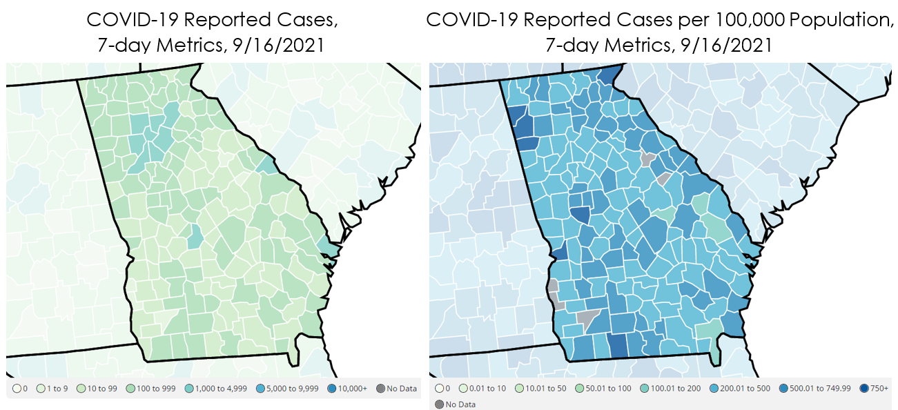
- Describe a situation involving geographic information in which it would be better to use a table or graph instead of a map. Explain why.
- The National Environmental Public Health Tracking Program partners with citizen science programs like Vermont’s Tick Tracker and Cyanobacteria Tracker that allow regular people to submit reports. This gives scientists data that helps them track public health threats. What are some benefits and drawbacks to citizen science programs like this?

