Sample data gathering tool for patients with recent/new hepatitis B or C virus infection without known risk factors for viral hepatitis to help guide health departments in identifying potential healthcare exposures that may warrant further public health investigation

Instructions: Gather available clinical and diagnostic data in Part 1 on pages 1-3. Use these data to calculate possible exposure period using guidance in Part 2 on pages 4-6. This time window may be used during the patient interview in Part 3 pages 7-16.

Part 1: Clinical and Diagnostic Data

Note: Clinical and Diagnostic Information may be transferred from the state department of health acute hepatitis case report form, and/or you may wish to review symptoms and dates with case patient during interview.

DATE laboratory report was received at Local Health Department __ __ / __ __ / __ __ __ __
(record results in next section)

REASON FOR TESTING: (Check all that apply)
__ Symptoms of acute hepatitis __ Evaluate elevated liver enzymes __ Screening of asymptomatic patient __ Blood / organ donor screening __ Follow-up testing for previous markers of viral hepatitis
__ Unknown
__ Other: specify: ____________

DIAGNOSIS: (Check all that apply)
__ Hepatitis B: ___ acute ___chronic ___unknown

__ Hepatitis C: ___ acute ___chronic ___unknown

CLINICAL DATA:
Diagnosis date: __ __ / __ __ / __ __ __ __
a. Was patient symptomatic? ___ Yes ___ No ___ Unk If yes, onset date: __ __ / __ __ / __ __ __ __

b. Was patient jaundiced? ___ Yes ___ No ___ Unk If yes, onset date: __ __ / __ __ / __ __ __ __

c. Did the patient experience:
Loss of appetite ___ Yes ___ No ___ Unk
Nausea ___ Yes ___ No ___ Unk
Vomiting ___ Yes ___ No ___ Unk
Abdominal Pain ___ Yes ___ No ___ Unk
Fever ___ Yes ___ No ___ Unk
Dark Urine ___ Yes ___ No ___ Unk
Other, specify_________________________

d. Was the patient hospitalized for hepatitis? ___Yes ___No ___Unk
If yes, admission date: __ __ / __ __ / __ __ __ __ discharge date*: __ __ / __ __ / __ __ __ __

Did patient die during admission? __yes ___no ____unk

If, yes, date of death: __ __ / __ __ / __ __ __ __

Diagnostic tests. Check all that apply. If tested on more than one date record all test results and dates through (including) date of first positive test.
Note: Creating a spreadsheet to depict evolving serology over time may be particularly useful for hepatitis B (sample attached at end of document).

___ Hepatitis B surface antigen [HBsAg] __Pos __Neg __Unk Date(s): ___/____/___
__Pos __Neg __Unk Date(s): ___/____/___

___ Total antibody to hepatitis B core antigen [total anti-HBc] __Pos __Neg __Unk Date(s): ___/____/___
__Pos __Neg __Unk Date(s): ___/____/___

___ IgM antibody to hepatitis B core antigen [IgM anti-HBc] __Pos __Neg __Unk Date(s): ___/____/___
__Pos __Neg __Unk Date(s): ___/____/___

___ HBV DNA __Pos __Neg __Unk Date(s): ___/____/___
__Pos __Neg __Unk Date(s): ___/____/___

If positive, (specify viral load(s) if available ________________

___ HBV Genotype result, if tested ______ Date: ___/____/____

___ Antibody to hepatitis C virus [anti-HCV] __Pos __Neg __Unk Date(s): ___/____/___
__Pos __Neg __Unk Date(s): ___/____/___

___ HCV RNA __Pos __Neg __Unk Date(s): ___/____/___
__Pos __Neg __Unk Date(s): ___/____/___

If positive, specify viral load(s) if available __________________

___ HCV Genotype result, if tested ______ Date: ___/____/____

___ Antibody to hepatitis D virus [anti-HDV] __Pos __Neg __Unk Date(s): ___/____/___

LIVER ENZYME LEVELS AT TIME OF DIAGNOSIS
ALT [SGPT] Result ______ Upper limit normal_______ Date __ __ / __ __ / __ __ __ __
AST [SGOT] Result ______ Upper limit normal_______ Date __ __ / __ __ / __ __ __ __

if known PRIOR LIVER ENZYME LEVELS, with baseline and first elevated level(s)
ALT [SGPT] Result ______ Upper limit normal_______ Date __ __ / __ __ / __ __ __ __
AST [SGOT] Result ______ Upper limit normal_______ Date __ __ / __ __ / __ __ __ __
ALT [SGPT] Result ______ Upper limit normal_______ Date __ __ / __ __ / __ __ __ __
AST [SGOT] Result ______ Upper limit normal_______ Date __ __ / __ __ / __ __ __ __
Part 2. Determining likely time period of HBV/HCV exposure (exposure window) based on laboratory and clinical findings

Note: This general guidance may not encompass all possible scenarios. CDC Division of Viral Hepatitis staff are always available for consultation at viralhepatitisoutbreak@cdc.gov or CDC-INFO 1-800-232-4636 (ask for Division of Viral hepatitis subject matter expert) See: https://www.cdc.gov/hepatitis/contactus.htm

1. For patients with a history of negative nucleic acid tests (NAT) or serology (for HBV, HBsAg and/or total anti-HBc; for HCV, anti-HCV) prior to the recent positive test:

Note: On average about 3 weeks (possibly up to 12 weeks) may elapse between initial infection and HBsAg/HBV DNA detectability, up to 6 months before anti-HCV seroconversion, and on average about one week (up to 2 weeks) before HCV RNA detectability.
See: https://www.cdc.gov/hepatitis/outbreaks/toolkit.htm

a. fill in date(s) and type(s) of most recent negative test(s). Include all serologic and NAT results.
__________ Date(s) __/__/___
__________ Date(s) __/__/___
__________ Date(s) __/__/___
__________ Date(s) __/__/___

b. fill in date(s) and type(s) of first positive test(s). Include all serologic and NAT results.

__________ Date(s) __/__/____
__________ Date(s) __/__/____
__________ Date(s) __/__/___
__________ Date(s) __/__/___

c. The possible HBV exposure window may be estimated using NAT for HBV DNA and/or HBsAg tests. On average about three weeks (typical range 1-9 weeks, possibly up to 12 weeks) may elapse between initial infection and HBsAg/HBV DNA detectability.

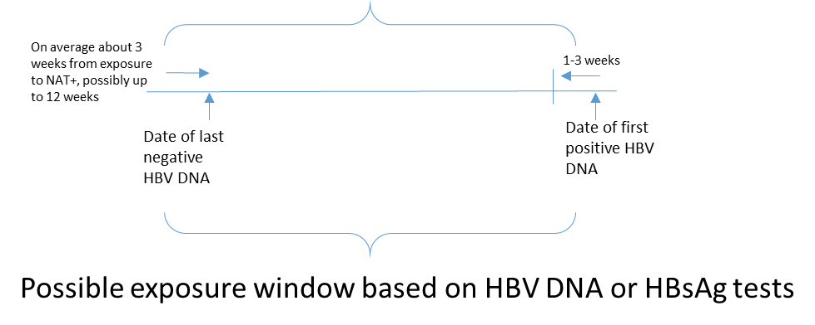

Likely exposure window: ___ /___/___ to ___ /___/___

d. The possible HCV exposure window may be estimated using NAT for HCV RNA and/or anti-HCV tests. For NAT on average the exposure may have been as early as one-two weeks prior to the last negative HCV NAT result, through one-two weeks before the first positive HCV RNA result. Using anti-HCV results the exposure may have been as early as 6 months prior to the last negative anti-HCV result through eight to 11 weeks prior to the first positive anti-HCV result.

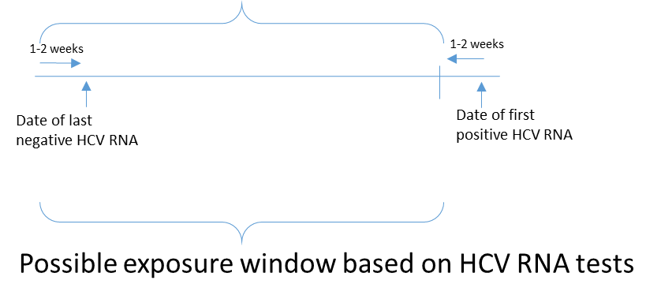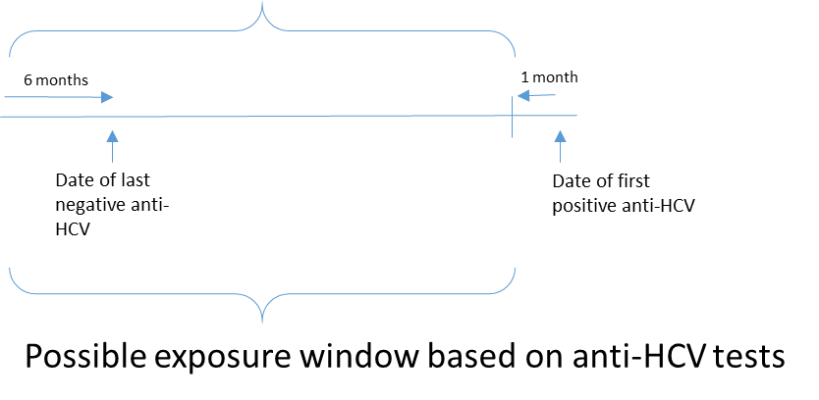

Likely exposure window: ___ /___/___ to ___ /___/___

e. Elevations in liver function tests when serial testing available, if noted and not clearly ascribed to other clinical comorbidites, may help to define the most likely time of exposure within the window defined by other lab tests. For HBV average time from exposure to first elevation is two months, range 40-90 days. For HCV the average time to first elevation can be as early as 2 weeks, degree and duration of ALT may be variable.

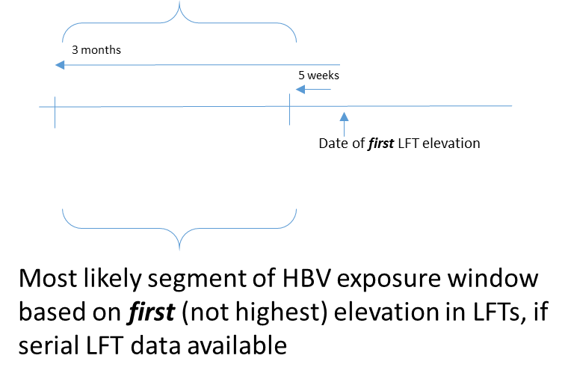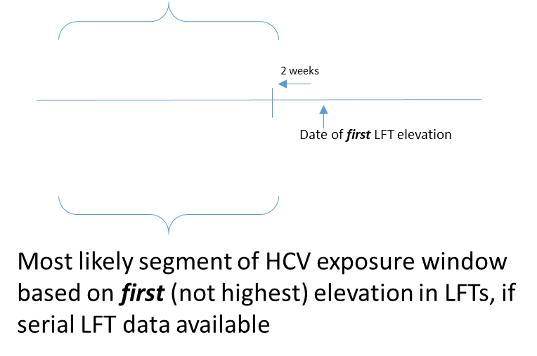

Likely exposure window: ___ /___/___ to ___ /___/___

2. For patients with discrete onset of signs/symptoms such as jaundice

Fill in date of onset and symptoms: ___________ Date __/__/____

For HBV the average onset of signs/symptoms (when present) is at 12 weeks after exposure, with a range of 9-21 weeks.

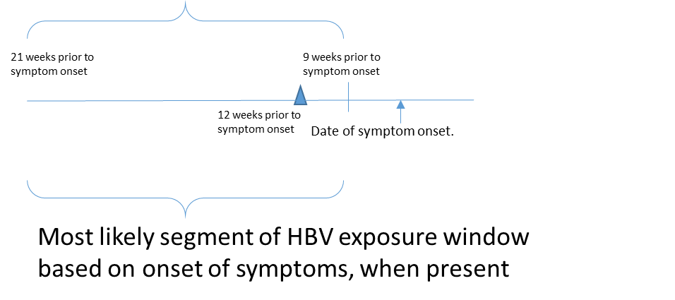

Likely exposure window: ___ /___/___ to ___ /___/___

For HCV the average onset of symptoms (when present) is 6-7 weeks after exposure with a range of 2-26 weeks.

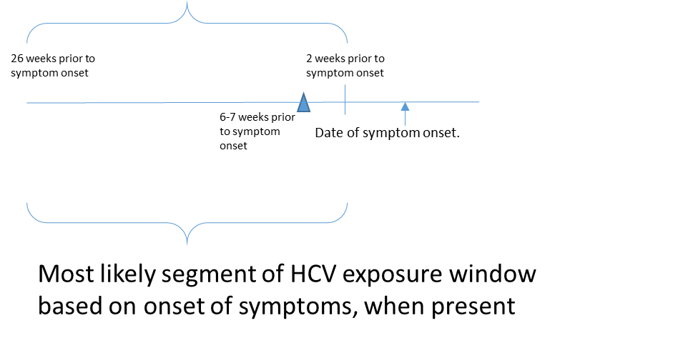
Likely exposure window: ___ /___/___ to ___ /___/___

3. For patients who have only a single positive test and no (or nonspecific) symptoms,
a. While an exact exposure window cannot be determined, recent potential healthcare exposures over a period of some months may be taken into consideration to determine possible times when exposure may have occurred that are most feasible for investigation.

Worksheet summarizing guidance for determining possible exposure window for persons with new HBV diagnosis

Options to Estimate First Date of Incubation Period |  |  |  |  |  | 1) Fill in the Date of Test: |  | 2) Subtract: |  |  | 3) Equals Estimated First Date of Incubation Period |  |  | Options to Estimate Last Date of Incubation Period |  | 4) Fill in the Date of Test: | 5) Subtract: | 6) Equals Estimated Last Date of Incubation Period
Last negative HBV DNA |  |  |  |  |  |  |  | 12 weeks |  |  |  |  |  | First positive HBV DNA |  |  | 1-3 weeks
Last negative HBsAg |  |  |  |  |  |  |  | 12 weeks |  |  |  |  |  | First positive HBsAg |  |  | 1-3 weeks
First elevation in ALT* |  |  |  |  |  |  |  | 3 months |  |  |  |  |  | First elevation in ALT* |  |  | 6 weeks
Onset of symptoms |  |  |  |  |  |  |  | 21 weeks |  |  |  |  |  | Onset of symptoms |  |  | 9 weeks
Single positive HBV DNA or HBsAg and no symptoms or prior test results |  |  |  |  |  |  |  | 1 year^
Summary Date(s): |  |  |  |  |  |  |  |  |  |  |  |  |  | Summary Date(s):
*This assumes that serial ALT levels are collected in an ongoing fashion.
^ This recommendation should be considered in the context of all available evidence. If no other data are available, this is a reasonable option.

Options to estimate first date of exposure window |  |  | 1) Fill in the date of test: |  | 2) Subtract: |  | 3) Equals estimated first date of exposure window | Options to estimate last date of exposure window |  | 4) Fill in the date of test: | 5) Subtract: | 6) Equals estimated last date of exposure window
Last negative HCV RNA |  |  |  |  | 1-2 weeks |  |  | First positive HCV RNA |  |  | 1-2 weeks
Last negative anti-HCV |  |  |  |  | 6 months |  |  | First positive anti-HCV |  |  | 8 weeks
 |  |  |  |  |  |  |  | First elevation in ALT* |  |  | 2 weeks
Onset of symptoms |  |  |  |  | 26 weeks |  |  | Onset of symptoms |  |  | 2 weeks
Single positive HCV RNA or anti-HCV and no symptoms or prior test results |  |  |  |  | 1 year^
Summary Date(s): |  |  |  |  |  |  |  | Summary Date(s):
*This assumes that serial ALT levels are collected in an ongoing fashion.
^ This recommendation should be considered in the context of all available evidence. If no other data are available, this is a reasonable option.

References

1. CDC. Healthcare notification and testing toolkit. Bloodborne Pathogens Testing. https://www.cdc.gov/hepatitis/outbreaks/toolkit.htm Accessed November 26, 2018.

2. CDC. Recommendations for Identification and Public Health Management of Persons with Chronic Hepatitis B Virus Infection. Morb Mortal Wkly Rpts 2008, 57 (RR08). https://www.cdc.gov/mmwr/preview/mmwrhtml/rr5708a1.htm

3. CDC. Recommendations for Prevention and Control of Hepatitis C Virus (HCV) Infection and HCV-Related Chronic Disease. Morb Mortal Wkly Rpts 1998, 47 (RR19). http://www.cdc.gov/mmwr/PDF/RR/RR4719.pdf

4. CDC. Viral Hepatitis Serology training: https://www.cdc.gov/hepatitis/resources/healthprofessionaltools.htm
Accessed 11/26/2018.

5. Association of Public Health Laboratories. Interpretation of Hepatitis C Virus Test Results: Guidance for Laboratories: https://www.aphl.org/aboutAPHL/publications/Documents/ID-2019Jan-HCV-Test-Result-Interpretation-Guide.pdf Accessed 1/28/2019.

Note that persons with past resolved HBV (HBsAg negative, total anti-HBc positive) or occult HBV infection (intermittent HBsAg positive with low-level or undetectable HBV DNA measurements; total anti-HBc positive) may reactivate to active HBV replication during periods of substantial immune compromise https://www.cdc.gov/hepatitis/hbv/hbvfaq.htm

Part 3. Sample PATIENT INTERVIEW
Note: questions for internal health department use only

Date Interview Completed (mm/dd/yy): ______/______/______ Interviewer _________

DEMOGRAPHIC INFORMATION

PRIMARY RESIDENCE: State: _______________ County: _________________________

RACE (check all that apply):
__American Indian/Alaska Native
__Black or African American
__White
__ Asian
__ Native Hawaiian or Other Pacific Islander
__ Other Race, specify: _________

ETHNICITY: Hispanic, Latino/a or Spanish origin? ___Yes ___No ___Unk

SEX: ___Male ___Female ___Unk

PLACE OF BIRTH: ___USA ___Other, specify:

DOB: __ __ / __ __/ __ __ __ __ AGE: ___ ___ (years)

MEDICAL INSURANCE:

___Private Insurance
___HMO ___Military
___Medicaid ___Medicare
___Uninsured
___Refused
___Unknown

OCCUPATION/SETTING:
___Food Service
___Day Care
___Health Care
___Student/School
___Corrections Works
___Other Occupation, specify:
____Unknown

PATIENT HISTORY
Note: encourage participants to have a calendar in front of them during the interview, and to gather other relevant paperwork, such as an appointment calendar, insurance statements, canceled checks or credit card statements. Some physicians also send email and text reminders for appointments and they may supply discharge instructions or after care instructions with a signature and date. Pill bottles will have date of prescription and might provide memory prompts if a prescription was written at the time of a procedure. Dates of holidays (July 4, Memorial Day, Thanksgiving …) can also serve as memory prompts. Some physicians also have an electronic patient portal that may provide information on dates of procedures. Informal date estimates may be checked against medical records.

1. Before your recent illness were you ever diagnosed with hepatitis? ___Yes ___No ___Unk
a. If yes, do you recall approximately when this occurred or what type of hepatitis it was (prompt: A, B, C, serum, infectious, autoimmune): type _________________ year __ __ __ __
If yes for hepatitis B or C: Did you develop chronic infection? ___Yes ___No ___Unk
b. If no, did you ever have an illness marked by jaundice (yellowing of the skin or eyes)?
___Yes ___No ___Unk

2. Have you tried to donate blood any time since 1970? ___Yes ___No ___Unk If yes, (specify most recent year __ __ __ __)
a. If yes, were you ever told that your blood could not be accepted or used? ___Yes ___No ___Unk If yes, please specify reason: __________________________________________

3. Did you ever receive hepatitis B vaccine? ___Yes ___No ___Unk
If yes, how many shots? ___1 ___2 ___3+
When was the last shot received? ___/____/_______

4. a. Do you have difficulty dressing, bathing, or getting around inside the home?
___Yes ___No ___Unk
b. Do you have difficulty going outside the home alone to shop or visit a doctor’s office?
___Yes ___No ___Unk

Read to patient: “For the remaining questions, the time period we are interested in is the likely exposure window, that is, the period between (fill in estimated dates) ___/____/____ and ___/____/____.”

5. During the exposure window were you a contact of a person who you were aware had acute or chronic hepatitis B or hepatitis C virus infection?
___Yes ___No ___Unk

If yes, specify type of contact:
___ Hepatitis B ___ Hepatitis C ___ hepatitis of unknown type
Household [Non-sexual]: ___Yes ___No ___Unk
Sexual: ___Yes ___No ___Unk
Other: _______________________________

6. During the exposure window did you:
a. Receive a tattoo or body piercing? ___Yes ___No ___Unk
If yes, specify location (for example, commercial tattoo parlor, prison, from a friend, at a tattoo or piercing party): _________________________________
b. Travel outside the United States or Canada? ___Yes ___No ___Unk
If Yes, specify locations (Country) and approximate dates:
1)__________________ from ___/____/____ to ___/____/____
2)__________________ from ___/____/____ to ___/____/____
3)__________________ from ___/____/____ to ___/____/____
c. Work in a medical field involving contact with human blood or body fluids?
___Yes ___No ___Unk
d. Work in a dental field involving contact with human blood or body fluids?
___Yes ___No ___Unk
e. Work in any other setting where you possibly could have had contact with human blood or body fluids? ___Yes ___No ___Unk
If yes, specify setting: _____________________________________
If yes, specify body fluid: ___________________________________
f. Have an accidental stick or puncture with a needle or other object possibly contaminated with human blood or body fluids? ___Yes ___No ___Unk
If yes, specify the date: __/___/___, setting: ___________________________________
If yes, specify body fluid: ___________________________________
g. Reside (live in) a long term care facility? ___Yes ___No ___Unk
If yes, for how long
h. Receive medical care in your home from visiting nurses or certified health professional?
___Yes ___No ___Unk If yes, specify:
1. Type of care provided
Frequency: ____ times/month or ____ times/week
2. Type of care provided Frequency: ____times/month or ____ times/week
3. Type of care provided Frequency: ____ times/month or ____ times/week 4. Type of care provided Frequency: ____ times/month or ____ times/week

i. Receive medical care in your home from relatives or other persons? ___Yes ___No ___Unk
If yes, specify and include dates on healthcare exposure table, final page:
1. Type of care provided Frequency: ____ times/month or ____ times/week 2. Type of care provided Frequency: ____times/month or ____ times/week
3. Type of care provided Frequency: ____ times/month or ____ times/week 4. Type of care provided Frequency: ____ times/month or ____ times/week

j. Go to a doctor, nurse, or other healthcare provider for any reason? ___Yes ___No ___Unk

7. In the next section, we will review some different types of health care encounters you may have had during the exposure window. (Note: if subject denies any healthcare whatsoever, explain that we still need to take a minute to review the following list because it includes some things that people sometimes don’t think of as healthcare. Use explanation of procedure in parenthesis if participant is not familiar with procedure.)

(Check all that apply)

PLEASE INDICATE WHETHER THE TREATMENT WAS RECEIVED AS A HOSPITAL INPATIENT (H), AT AN OUTPATIENT CLINIC (O), OR BOTH

- Dental work or visit a dentist
- Podiatry care (i.e., did you see a foot doctor)?
- Skin care procedure (i.e., from a dermatologist)?
- Cosmetic procedure (i.e. from a dermatologist or plastic surgeon)?
- Blood sugar [glucose] levels:
If yes, did you share any testing equipment with another person? ___Yes ___No ___Unk
If yes, specify: fingerstick device / lancet / meter / other ____________________
- Fingerstick for blood donor assessment or any other reason?
- Blood tests (i.e., have blood drawn)
- Dialysis (Blood is pumped from the body into a filter (dialyzer) where waste products and extra fluid are removed. The filtered blood is then pumped back into the body)
- Apheresis (Blood is pumped from the body and a component of blood is removed from the blood. The blood is then pumped back into the body)
- Flu shot or other vaccines
- Shots for arthritis or joint problems
- Steroid injections
- Injections for pain relief or other treatment at a pain clinic
- Allergy injections
- Vitamin injections (i.e. B₁₂)
- Care from a traditional healer or herbalist
- Injections of any kind not already mentioned
- Acupuncture
- Chelation therapy (A chemical process in which a synthetic solution—EDTA is injected into the bloodstream to remove heavy metals and/or minerals from the body (used to treat lead poisoning)
- Chemotherapy for cancer treatment
- Blood products including transfusion or platelets
- Intravenous (IV) fluids or medicines not already mentioned
- Radiation therapy
- X-rays
- Imaging scans (including CAT-scans, PET-scans, MRI)
(CAT scan or Computer axial tomography uses X-rays and computers to produce an image of a cross-section of the body. Dye may be injected into a vein or taken orally so the radiologist can better see the body structures better)
(PET scan or Positron emission tomography is a test that combines computed tomography (CT) and nuclear scanning. During a PET scan, a radioactive substance called a tracer is combined with a chemical (such as glucose); this mixture is generally injected into a vein (usually in the arm) but on occasion may be inhaled.)
(MRI or Magnetic resonance imaging is a test that uses a magnetic field and pulses of radio wave energy to make pictures of organs and structures inside the body)
- Any other imaging exams, specify:
- Injected Imaging Dye (From one of the above imaging tests or another imaging test)
Specify:
- Vaginal ultrasound (ASK FEMALES ONLY. A technician inserts a sonogram probe into the vagina and aims sound waves into the pelvic cavity to take pictures of reproductive organs)
- Hospital emergency department visit
- Hospitalization requiring overnight stay
- Anesthesia (Medicine to “put you to sleep” or make you numb to pain during a medical procedure)
- Surgery or any operation as inpatient or outpatient
- Biopsies as inpatient or outpatient (A small sample of tissue is removed from an area of the body to test for cancers or other health conditions)
- Wound care
- Colonoscopy (Colonoscopy is a test to look at the interior lining of the large intestine via a scope)
- Sigmoidoscopy (Similar to a colonoscopy but only shows the rectum and the lower third of the colon)
- Other endoscopy (Endoscopy is a nonsurgical procedure used to examine a person's digestive tract)
- Laparoscopic procedures (Laparoscopy is a surgical procedure that uses a thin, lighted tube called a laparoscope inserted through an incision in the abdominal wall to examine the abdominal organs or female pelvic organs)
- Arthroscopic procedures (Arthroscopy is a surgical procedure to look at the inside of a joint in the body through a thin viewing instrument called an arthroscope)
- Any other procedure referred to as “scoping” such as cystoscopy and ureteroscopy (A cystoscopy or ureteroscopy is a procedure where your physician inserts a flexible scope through your urethra to see inside your bladder and/or urethra)
Specify:
- Cardiac catheterization (A thin flexible tube called a catheter is threaded through a blood vessel in your arm or groin and into your heart. Through the catheter, your doctor can measure pressures, take blood samples, and inject contrast material into the coronary arteries to trace the movement of blood through the arteries)
- Cataract or other eye surgery
- Laser procedures, specify:
- Medical procedure or operation not already mentioned

Note: If the respondent answered yes to any of the above, complete the Healthcare Event Table at the end.

SENSITIVE QUESTIONS:
I will now ask you several questions that may be of a sensitive nature, but which are important because these activities can explain why some people become infected with hepatitis B or C. Remember that all the information you share is confidential and you can refuse to answer any of the questions. However it would be helpful to have a complete response.

8. During exposure window, did you have any sexual partners? ___Yes ___No ___Unk

If Yes, a. How many female sex partners did you have? ________ (number of partners)
- How many male sex partners did you have? ________ (number of partners)

9. During exposure window, did you
a. Inject with a needle any drug that was not prescribed by a doctor? ___Yes ___No ___Unk
b. Use street drugs but not inject with a needle (for example snorted)? ___Yes ___No ___Unk
c. Spend more than 24 hours in jail or prison? ___Yes ___No ___Unk

10. Have you ever in your life injected drugs with a needle not prescribed by a doctor?
___Yes ___No ___Unk

MISCELLANEOUS:

11. In the exposure window, were you involved in any situations that exposed you to someone else’s blood that was not otherwise covered by this survey? ___Yes ___No ___Unk
If yes, specify: ____________________________________________________________________

12. How do you think you got hepatitis?

Thank you. I appreciate the information you provided.

Do you have any other questions about the interview, or hepatitis?

SAMPLE HEALTHCARE EXPOSURES TABLE
Example spreadsheet for tracking evolving HBV serology and clinical events over time

Date | 12/21/2017 | 1/4/2018 | 1/9/2018 | 2/23/2018 | 3/12/2018 | 3/14/2018 | 4/3/2018 | 4/9/2018 | 4/13/2018 | 5/6/2018 | 5/23/2018 | 5/30/2018
Location | hospital in state x | outpatient dialysis facility in state x, # patients | " | outpatient dialysis facility in state y, # patients | " | " | " | " | " | " | " | "
Event | First-ever dialysis |  | HBV vaccine dose |  |  | started dialysis in isolation for first time
Labs |  | HBsAg negative, anti-HBs negative, total anti-HBc negative |  | routine monthly HBsAg screen = positive, total anti-HBc negative, | HBsAg positive | HBV DNA = 7676 copies or IU/mL | HBeAg positive, HBsAg positive, HBV DNA positive, total anti-HBc negative | IgM anti-HBc negative | total anti-HBc negative | HBV DNA> 100 e⁷ , total anti-HBc negative, anti-HBs negative | HBsAg positive | total anti-HBc positive, HBsAg positive, anti-HBs negative
Notes (index case age, sex, race, state of residence, other medical conditions) |  |  |  | exposure would have been 1 to 12 weeks prior to this date |  | facility screens new pts for HBsAg and anti-HBs; every susceptible screened 2nd Tues each month.  Note: no additional cases identified in 6 months of testing. |  | appears to have resolved acute IgM by this time |  | consistent with evolving acute infection |  | consistent with evolving acute infection

