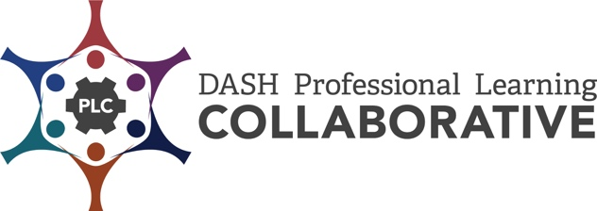

CDC Professional Development Practices Inventory

The CDC Professional Development Practices (PDPs) are a series of steps based on research and best practices. When effectively applied, they increase active learner engagement and provide optimal conditions for the transfer of learning and implementation of the knowledge and skills in the work setting. These practices provide a process to achieve sustainability over time.
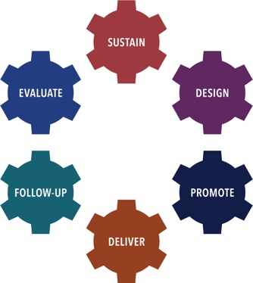 | There are six PD Practices used as the framework for this inventory:  - Sustain a PD Infrastructure,  - Design PD Offerings,  - Promote PD Offerings,  - Deliver PD,  - Provide Follow-Up Support, and  - Evaluate PD Processes.

The CDC Professional Development (PD) Practices Inventory was developed to assist DASH funded partners in identifying best practices and processes for establishing a comprehensive professional development (PD) program. The Inventory is designed as a tool for an individual and/or team to assess strengths, areas of growth, priorities, and next steps in the implementation of the CDC PD Practices.
Directions:
- Individually, or with other colleagues responsible for providing effective professional development, review all or selected CDC PD Practice Inventory items.
- Decide if each CDC PD Practice item is “not yet in place”, “partially in place”, “mostly in place”, or “fully in place”.
- Determine your strengths and areas of growth for each CDC PD Practice reviewed.
- Identify your priorities and next steps to implement each CDC PD Practice reviewed.

DASH Definitions:
Professional Development (PD) is an intentionally designed, systematic process used to strengthen the knowledge, skills, and attitudes of a particular workforce. The goal of PD, in the context of Centers for Disease Control and Prevention’s (CDC’s) Division of Adolescent and School Health (DASH) priorities, is to help improve the health, education, and well-being of youth. Professional development contributes to this goal by enhancing the knowledge, skills, and attitudes of health and education professionals so that they can more effectively implement strategies that positively impact young people. The strategies may support classroom management, effective teaching, and the DASH strategies, such as sexual health education, sexual health services, and safe and supportive environments.

- Professional Development Event is a set of skill-building processes and activities designed to assist targeted groups of participants in mastering specific learning objectives. Such events are delivered in an adequate time span (at least three hours) and may include curriculum and other training, workshops, and online or distance learning courses.

- Professional Development Offering is events, information and presentation sessions, and technical assistance.

- Technical Assistance is targeted support provided to an individual or group of individuals with the intent to increase knowledge and skills to strengthen an organization’s capacity to achieve PS18-1807 NOFO goals. Support may be provided through professional development events, technical assistance, the provision of guidance and resource materials, or referrals to other agencies or organizations.

Sustain a PD Infrastructure  Understand and leverage the existing structure and practices for providing PD in your agency. | 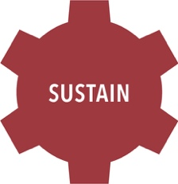

Processes to Establish, if necessary, an Infrastructure  Steps for this include: | Not yet in place | Partially in Place | Mostly in Place | Fully in Place
Identify a person to provide leadership and accountability for all PD efforts.
Work within your agency to ensure that there are policies and procedures to support effective PD.
Secure financial and human resources to support PD and collaboration.
Establish a clearly defined process to support PD providers.
Establish a system to record and manage your data.

Processes to Sustain a PD Infrastructure  Sustaining a PD infrastructure relies on a clearly defined plan and high standards of practice. Steps for this include: | Not in Place | Partially in Place | Mostly in Place | Fully in Place
Establish and implement an overall PD plan that addresses all required PD activities and incorporates the PDPs.
Ensure PD plan is in alignment with state and local PD policies and practices.
Develop a process for recruitment, development, and assessment of qualified PD providers; consultants may be external or in-house.
Provide skilled PD providers who can implement the results-based PD plan.
Confirm that PD providers:
- Apply the fundamentals of effective training design and delivery.
- Have content expertise and experience.
- Apply adult learning principles.
- Meet the needs of diverse learners by using a variety of teaching and learning strategies.
- Create a safe and functional learning environment for participants.
- Are skilled at managing conflict/controversy.
Provide ongoing assistance for PD providers to foster continuous growth.

Establish / Sustain a PD Infrastructure
Strengths: | Areas of Growth:

Establish / Sustain a PD Infrastructure – Priorities / Next Steps | By When | Person Responsible

Design PD Offerings  Design offerings and technical assistance that are based on adult learning research, content-based learning theory, and best practice. Align the length of the PD offering with specific learning objectives. The Design practice emphasizes thoughtful and intentional planning for all PD experiences. | 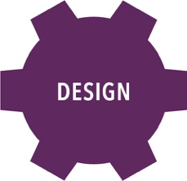

Processes to Design PD Offerings  For each group PD session offered: | Not yet in place | Partially in Place | Mostly in Place | Fully in Place
Identify the primary target audience.
Conduct a pre-assessment and/or review available data to guide the development of specific, measurable and feasible learning objectives.
Develop a PD event or offering that includes:
- Detailed agenda for the trainer and/or PD provider.
- Pre-work and/or homework plan.
- Participant action plan.
- Promotion plan (see Promote).
- Transfer of learning techniques (see Follow-up Support).
- Evaluation plan (see Evaluate).
Develop, design, and organize materials.
Manage or hire someone to manage logistics (e.g., registration, venue, AV/technology).

Processes to Design PD Offerings  For each one-on-one technical assistance offered: | Not yet in place | Partially in Place | Mostly in Place | Fully in Place
Establish and follow a technical assistance (TA) protocol that includes:
- Process for establishing scope of TA need.
- Expected results.
- Determining a TA Provider with content expertise.
Develop a plan for TA delivery that includes:
- Content to cover.
- Data sources.
- Estimated time.
- Resources.
Include a follow-up support plan (see Follow-up Support).
Plan for evaluation, as applicable (see Evaluate), including:
- Tracking TA process and outcomes.

Design PD Offerings
Strengths: | Areas of Growth:

Design PD Offerings – Priorities / Next Steps | By When | Person Responsible

Promote PD Offerings
Know your target audience and use promotional strategies that capture their attention and interest.
You want them to request your PD offerings. Keep communication clear and simple, emphasizing what participants will learn and be able to do as a result of participating in the PD offering. Focus on how attending your PD offering will help them in their classrooms and work environments.

Processes to Promote PD Offerings | Not yet in place | Partially in Place | Mostly in Place | Fully in Place
Determine the PD offering that will match the primary target audience needs and availability.
Develop a comprehensive promotion plan. Steps for this include:
- Develop SMART (Specific, Measurable, Achievable, Realistic, and Time-phased) objectives that describe the promotion results to be achieved.
- Develop and pre-test messages and materials that will resonate with target audiences.
- Determine how promotional messages will be disseminated to effectively reach target audiences (e.g., social media, blast email, flyers).
- Create a promotional timeline including milestones and measures of success.
- Recruit partners who can support and assist in achieving promotion objectives.
Implement the promotion plan.
Collect and record promotion evaluation data (see Evaluate).
Monitor and adjust promotion plan, materials, and messages based on feedback and results.

Promote PD Offerings
Strengths: | Areas of Growth:

Promote PD Offerings – Priorities / Next Steps | By When | Person Responsible

Deliver PD  Facilitate PD offerings using the design you developed to positively impact learning and create change.  The Deliver practice is operationalized when the design, promotion, follow-up support, and evaluation  practices come together in an effort to provide effective professional development offerings. Assess these delivery characteristics to ensure they are addressed throughout the professional development offering. | 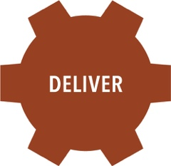

Processes to Deliver PD | Not yet in place | Partially in Place | Mostly in Place | Fully in Place
Provide an environment conducive to learning.
Use qualified PD providers (see Sustain).
Facilitate the PD offering, a group session or one-on-one TA.
Collect participation and registration data.
Provide and manage materials.
Manage AV/technology/resources.
Share plan to support transfer of learning and next steps.
Collect and record evaluation data from each PD offering, a group session or one-on-one TA (see Evaluate).

Deliver PD
Strengths: | Areas of Growth:

Deliver PD – Priorities / Next Steps | By When | Person Responsible

Provide Follow-Up Support  Reinforce the knowledge and strengthen the skills of your participants through continued and targeted follow-up support. The Follow-up Support practice reinforces the transfer of learning. Transfer of learning refers to learning in one context and applying it to another. Applying transfer of learning includes retaining the knowledge and skills from the PD offering, and then applying and sustaining what was learned in their work environment. | 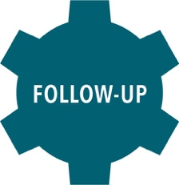

Processes to Provide Follow-Up Support  For each PD Offering: | Not yet in place | Partially in Place | Mostly in Place | Fully in Place
Plan follow-up support for transfer of learning during design phase.
Share follow-up support expectations prior to and during the PD offering.
Schedule follow-up support.
Conduct follow-up support at appropriate intervals.
Document delivery of follow-up support (e.g., who, what, when).
Collect and record follow-up support evaluation data in management system (see Evaluate).

Provide Follow-Up Support
Strengths: | Areas of Growth:

Provide Follow-Up Support – Priorities / Next Steps | By When | Person Responsible

Evaluate PD Processes  Collect usable data throughout the PD process. Use these data to inform your PD plan and report your successes and lessons learned. The Evaluate practice systematically monitors and evaluates your professional development offerings by collecting data and using it to improve future efforts. | 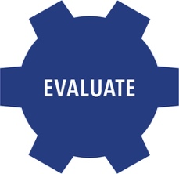

Processes to Evaluate PD Processes | Not yet in place | Partially in Place | Mostly in Place | Fully in Place
Assess PD needs of the target audience, as applicable (see Design).
Develop a plan, per DASH’s PD Evaluation Toolkit guidelines, to measure the PD offering learning objectives. This may include collecting information about the transfer of learning after the PD offering, if applicable and resources allow.
Identify or develop instruments to collect evaluation data from multiple sources.
Collect evaluation data related to promotion, PD offerings, TA delivery, and follow-up support (see Promote, Deliver and Follow-Up Support).
Determine whether PD offering goals and objectives were achieved.
Use a data entry protocol.
Maintain evaluation data in an organized data management system.
Report evaluation results to stakeholders to facilitate use of the findings.

Evaluate PD Processes
Strengths: | Areas of Growth:

Evaluate PD Processes – Priorities / Next Steps | By When | Person Responsible

Modified by the ICF-CDC DASH Professional Learning Collaborative (PLC), 2019. Adapted from CDC DASH Professional Development Practices - Inventory | ETR-CDC DASH Professional Learning Collaborative (PLC), 2015. Original version created by RMC Health-CDC DASH Professional Development Partnership (PDP), 2009

