Nutritional Anthropometry: Collecting and Analyzing Nutritional Data

Introduction

Epi Info™ 7 contains several nutritional anthropometry tools used to collect, analyze, and graph child growth data. Formerly referred to as the NutStat module, the Nutritional Anthropometry tools now include a data entry form that calculates z-scores and percentiles as data are entered, creates growth charts in Visual Dashboard, and has the ability to add z-scores and percentiles to existing datasets.
Four growth references are available for use: CDC 2000 Growth Reference, WHO Child Growth Standards, WHO Reference 2007, and CDC/WHO 1978. Except for the Nutrition project forms, all nutritional anthropometry tools in Epi Info™ 7 can easily select the required growth reference.

The Nutrition Project

The Nutrition Project is a specialized project that can be opened in the Enter tool or modified in Form Designer. The Nutrition form contains fields that collect a child’s age, height, weight, and other measurements for each clinic or doctor’s office visit. Based on these measurements, the appropriate z-scores and percentiles are automatically calculated and added to the dataset. The WHO Child Growth Standards are used to calculate z-scores for children 0 to 2 years of age and the CDC 2000 reference is used to calculate z-scores for children 2 years of age and older. For additional information, see the CDC Growth Charts Web page. (www.cdc.gov/growthcharts).

Opening the Nutrition Form
To open the Nutrition project:
- From the Epi Info™ 7 menu, click the Enter Data button or Tools > Enter Data. The Enter Data tool opens.
- From the toolbar, click the Open Form button. The Open Form dialog box appears.
- Click the ellipsis next to the Current Project text box. The Select a Project dialog box appears.
- Navigate to the Projects subfolder. A list of projects appears.
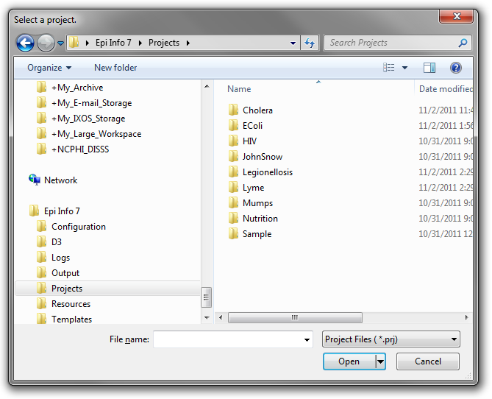
Figure 11.1: Project’s subfolder
- Select the Nutrition folder. Click Open.
- Select the Nutrition project file. Click Open. The Open Form dialog reappears with a list of available forms to select.
- From the list of forms, select Nutrition.
- Click OK. The Nutrition form appears in the Enter Data tool.
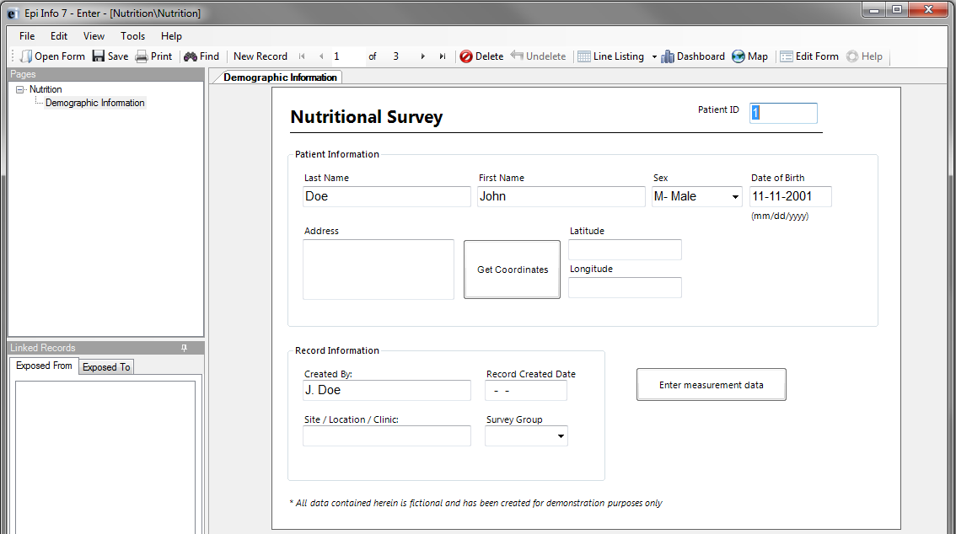
Figure 11.2: The Nutrition Form

Using the Nutrition Form
After the Nutrition Form is opened, data can be entered, modified, and deleted in the same manner as other Epi Info™ 7 forms. Each record in the Nutrition form represents a single child. The form contains the optional capability to geocode the child’s home address into latitude and longitude coordinates with the Get Coordinates button. Reference the Enter Data section of this user guide for additional information regarding the data entry process.
Although the data entry form contains only one record per child, each child may have been measured at multiple points in time. The Nutrition project has the ability to capture multiple measurements for each child, which is essential for calculating statistics and generating graphs. The Nutrition form has a related form called PatientVisits to store measurement information over time. The PatientVisits form may have one or more associated records. Clicking the Enter Measurement Data button will access the PatientVisits form.
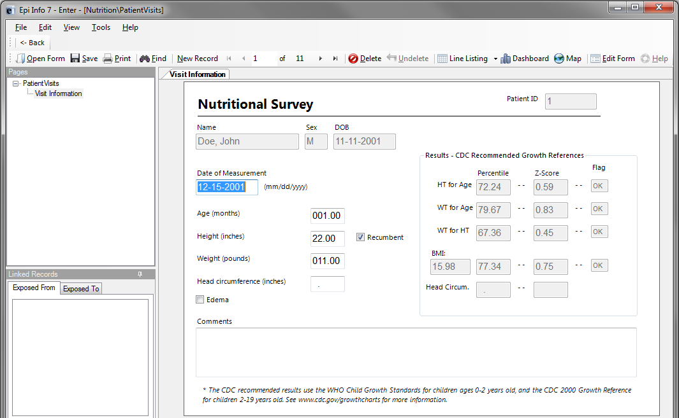
Figure 11.3: PatientVisits Form
The patient’s name, sex, date of birth, and ID number automatically appear in the form. These values link the records in this form to the child’s nutritional record in the Nutrition form. As you type values into the PatientVisits form (e.g., date of measurement, age in months, height, weight, etc.) the z-scores and percentiles are automatically calculated and appear in the form.
Add measurement records by clicking the New Record button on the toolbar. Clicking the <- Back button closes the PatientsVisits form and returns you to the Nutrition form.
The relationship between these two forms defines how information is stored and calculated. For each record in the Nutrition form, there may be one or more linked record(s) in the PatientVisits form. If the user is viewing record #1 in the Nutrition form, clicking the Enter Measurement Data button will take the user to all of the measurements associated with that particular child (and no others). See the following figure for a visual explanation of the relationship. Note that the blue squares represent records in the Nutrition form, and the red squares represent records in the PatientVisits form.
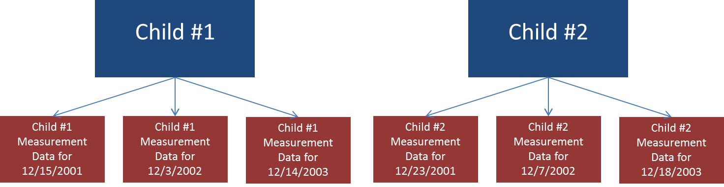
Figure 11.4: Nutrition (blue, top) and PatientVisits form (red, bottom) Relationship
To view Child #1’s measurement information on 12/15/2001, navigate to Child #1’s record in the Nutrition form. Click Enter Measurement Data and navigate to the record that has 12/15//2001 as the date of measurement.
Note: The data included in the Nutrition project may differ from that displayed in the figure above.

Customizing the Nutrition Forms
The Nutrition forms can be customized to include or exclude any field or check code in the form. For example, if geocoding the child’s address into latitude and longitude is not necessary, those fields can be deleted. The form’s title, Nutritional Survey, can also be changed.
Note: Removing fields or changing field names may disable the underlying z-score and percentile calculations.
For additional information regarding form editing, reference the Form Designer section of the user guide.

NutStat Growth Charts in Visual Dashboard

Based on a child’s measurements, a growth chart can be created in Visual Dashboard to track the progress of a particular child (Displaying multiple children on a single chart is not an available option). The NutStat growth charts can be accessed in Visual Dashboard by right clicking on the canvas and then selecting Add Nutstat growth chart.
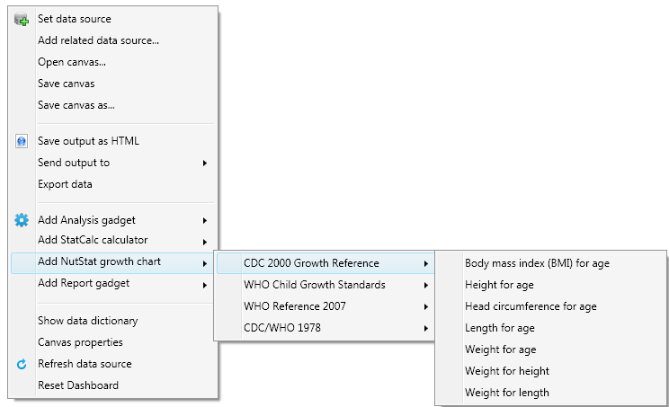
Figure 11.5: Growth Chart Types
There are four growth references available for use: CDC 2000 Growth Reference, WHO Child Growth Standards, WHO Reference 2007, and CDC/WHO 1978. Each growth reference contains different options for creating a growth chart and each chart requires the associated data.
Note: The Nutrition project does not contain example data to create all chart types.

Loading Nutritional Data
Prior to creating a growth chart, nutritional data must be loaded into the dashboard. Follow the steps below to load the data associated with the Nutrition project into the dashboard.
- From the Epi Info™ main menu, click the Visual Dashboard button or select Tools > Analyze Data > Visual Dashboard. The Dashboard tool appears.
- Right-click on the dashboard canvas. A context menu appears.
- Select Set Data Source from the context menu. The Select Data Source dialog box appears.
- Click the ellipses next to the Data Source text box. A file open dialog box appears.
- Navigate to the Epi Info™ projects folder.
- Open the Nutrition folder within the projects folder.
- Select the Nutrition project. Click Open.
- In the Select Data Source dialog box, select the PatientVisits form. Click OK. The data is loaded on the dashboard.
After the PatientVisits form is loaded, the dashboard will have cached the data in the computer’s memory. Based on the data, various types of statistical tools or gadgets can be added to the canvas to display useful information to the user. For information regarding the statistical tools and gadgets available, reference the Visual Dashboard section of this user guide.

Creating a Growth Chart
There are many growth charting options available under Add NutStat growth chart in Visual Dashboard. The available growth chart types are dependent on each growth reference and require the necessary project data.
Note: The Nutrition project does not contain example data for every growth chart type.
The following examples demonstrate how to create a growth chart with data contained in the Nutrition project. All growth charts created in Visual Dashboard use similar processes outlined in the examples below.

BMI for Age
The following example demonstrates how to create a BMI for Age growth chart using the CDC 2000 Growth Reference. The growth chart will demonstrate how the patient’s BMI compares to the CDC 2000 Growth Reference by age.
- Right-click on the dashboard canvas. A context menu appears.
- Select Add NutStat Growth Chart > CDC 2000 Growth Reference > Body Mass Index (BMI) for Age from the list of options in the context menu. A growth chart gadget appears on the canvas.
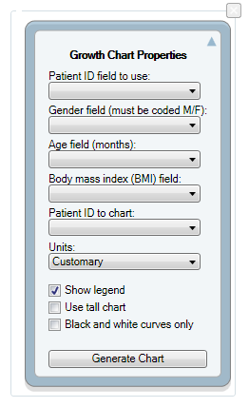
Figure 11.6: Growth Chart Gadget
The gadget must specify what fields to use for the Patient ID, Gender, Age, Body mass index (BMI), and the Patient ID to chart.

- Select VisitPatientID for Patient ID field to use.
- Select VisitSex for Gender field (must be coded M/F).
- Select AgeMonths for Age field (months).
- Select BMI for Body mass index (BMI) field.
- Select 1 for Patient ID to chart.
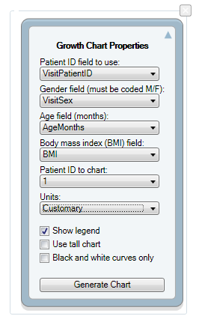
Figure 11.7: Completed Growth Chart Gadget
The checkboxes below the drop-down lists allow for customizing the appearance of the graph.
- Show legend – adds a legend to the graph (checked by default)
- Use tall chart – extends the vertical height of the growth chart
- Black and white curves only – all curves appear in black and white (color is removed)
- Click the Generate Chart button. The growth chart appears on the canvas.
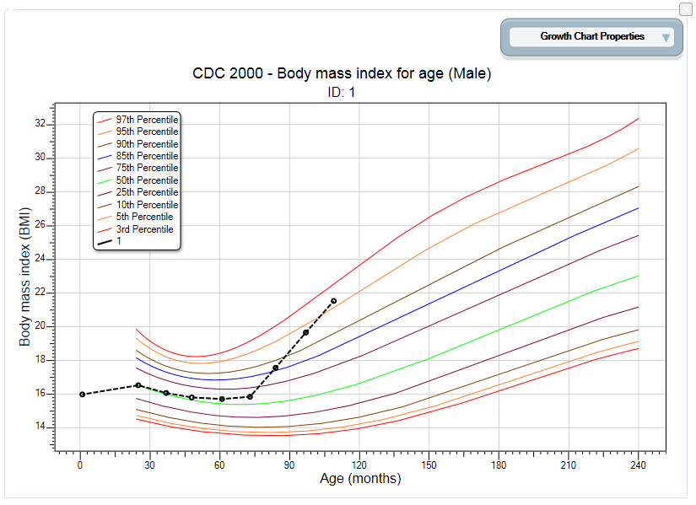
Figure 11.8: BMI for Age Growth Chart
- To collapse the panel and show only the chart, click the up arrow at the top right corner of the properties panel. Click the down arrow to expand the properties panel.

Height for Age
The following example demonstrates how to create a Height for Age growth chart using the CDC/WHO 1978 growth reference. The growth chart will demonstrate how the patient’s height compares to CDC/WHO 1978 standards by age.
- Right-click on the dashboard canvas. A context menu appears.
- Select Add NutStat Growth Chart > CDC/WHO 1978> Height for Age from the list of options in the context menu. A growth charting gadget appears on the canvas.
- Select VisitPatientID for Patient ID field to use.
- Select VisitSex for Gender field (must be coded M/F).
- Select AgeMonths for Age field (months).
- Select HeightInches for Height field.
- Select 1 for Patient ID to chart.
- Click the Generate Chart button. The chart appears as shown below.

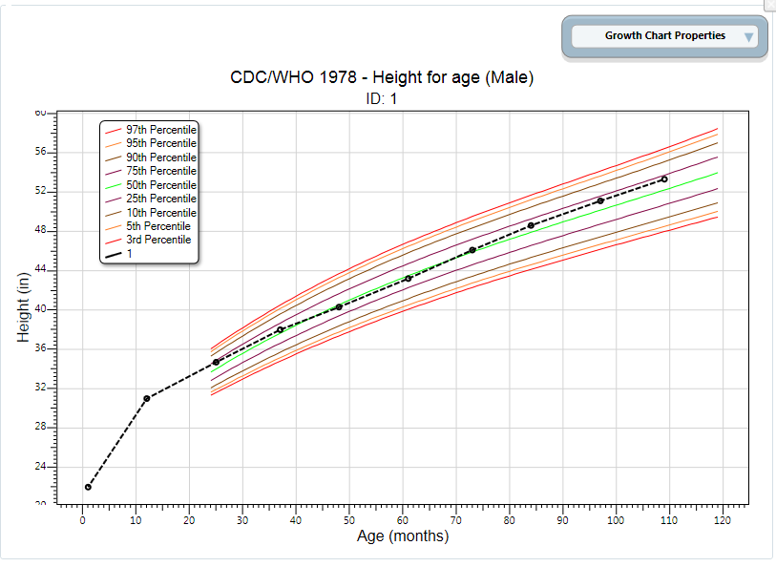
Figure 11.9: Height for Age Growth Chart
- To collapse the panel and show only the chart, click the up arrow at the top right corner of the properties panel. Click the down arrow to expand the properties panel.

Length for Age
The following example demonstrates how to create a Length for Age growth chart using the WHO Child Growth Standards. The growth chart will demonstrate how the patient’s length compares to WHO Child Growth Standards by age.
Note: The Length for Age chart requires similar inputs as the Height for Age chart but additionally requires the user to check the Recumbent check box in the PatientVisits form during data entry.
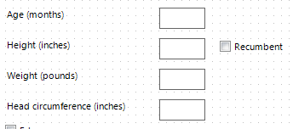
Figure 11.10: Recumbent checkbox in PatientsVisit form during data entry
- Right-click on the dashboard canvas. A context menu appears.
- Select Add NutStat Growth Chart > WHO Child Growth Standards > Length for Age from the list of options in the context menu. A growth charting gadget appears on the canvas.
- Select VisitPatientID for Patient ID field to use.
- Select VisitSex for Gender field (must be coded M/F).
- Select AgeMonths for Age field (months).
- Select HeightInches for Length field. (If recumbent was checked during data entry, the height field converts to length)
- Select 1 for Patient ID to chart.
- Click the Generate Chart button. The chart will appear as shown below.
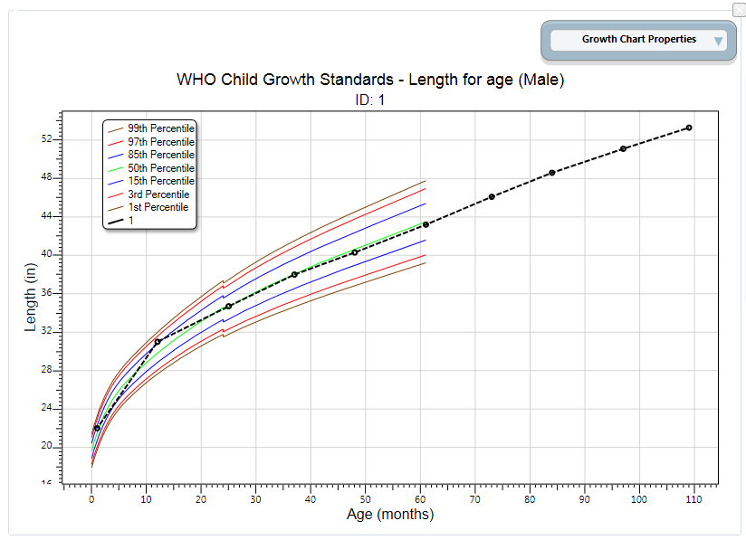
Figure 11.11: Length for Age Growth Chart
- To collapse the panel and show only the chart, click the up arrow at the top right corner of the properties panel. Click the down arrow to expand the properties panel.
It is important to note some aspects of the growth charting capabilities. First, there must be a patient ID field to identify a single person within the database. In the examples above, all of the records from the patient with an ID value of 1 were charted. Second, the field storing gender information must code that information as M and F. The dashboard has data recoding capabilities that can be used to change gender information to other formats. No matter what format represents male and female, it can be converted. In the examples above, no conversion was necessary. Third, the field storing the age values must be in months. Similar to gender, the dashboard can convert ages stored in days and years into months. Fourth, all properties can be changed in order to re-generate the chart. However, changing the chart inputs and growth references is subject to the data available and the available chart types. Finally, the growth charts can be used with non-Epi Info™ 7 projects, including projects that do not have the z-scores and percentiles already calculated.

Using the Nutrition Functions

There may be cases where nutritional data have already been collected in another program (e.g., Microsoft Excel) but the z-scores and percentiles are missing. Re-entering all of this data into the Epi Info™ 7 Nutrition project would be inefficient and time-consuming.
The Epi Info™ 7 Classic Analysis tool contains two specialized functions, ZSCORE and PFROMZ, that can add z-scores and percentiles to an existing set of data. For additional information on the Classic Analysis tool, reference the Classic Analysis section of this user guide.

The ZSCORE Function
The ZSCORE function takes a series of parameters and returns a z-score (z statistic) based on those parameters. The nutritional parameters include:
- Growth reference set (i.e., the CDC 2000 Growth Reference).
- Type of z-score (i.e., body mass index for age).
- Name of the column that stores the primary measurement (i.e., BMI).
- Name of the column that stores the secondary measurement (i.e., AgeMonths).
- Name of the column that stores the child’s gender, stored as 1’s and 2’s.
Note: The data available in the Nutrition project stores gender information as M and F and must be converted to 1’s and 2’s.
Each parameter is separated by a comma, and the entire series of parameters are enclosed in parenthesis. If you wish to calculate body mass index for age using the CDC 2000 Growth Reference, the function must reference the child’s raw BMI (column BMI), the child’s age in months (column AgeMonths), and the child’s gender (column Gender). The function will be similar to the following:
ZSCORE("CDC 2000", "BMI", BMI, AgeMonths, Gender)
The first parameter is “CDC 2000”. The quotes are required as the first two parameters are literal values (i.e. fixed values, the calculations will always refer to the exact CDC 2000 value). The full set of valid references that can be used for this parameter are listed below.
Parameter value | Reference
CDC 2000 | CDC 2000 Growth References
WHO CGS | WHO Child Growth Standards (0-5 years)
WHO 2007 | WHO Reference 2007 (5-19 years)
NCHS 1977 | CDC/WHO 1977 Growth Reference
Figure 11.12: Valid Values for First Parameter
The second parameter, “BMI”, tells the program to calculate a z-score for body mass index for age. The quotes for this second parameter are also required. The full set of valid z-score types that can be used for the second parameter are listed below. Not all growth references support all types of z-score calculations (i.e., “BMI” may be valid for CDC 2000, but it is not supported when using the NCHS 1977 growth reference).
Parameter value | Type of z-score
BMI | Body mass index-for-age
HtAge | Height-for-age
WtAge | Weight-for-age
WtHt | Weight-for-height
WtLgth | Weight-for-length
HeadCircum | Head circumference-for-age
LgthAge | Length-for-age
Ssf | Subscapular skinfold-for-age
Tsf | Triceps skinfold-for-age
Figure 11.13: Valid Values for Second Parameter
The third parameter is also BMI, but does not contain any quotes because this parameter is the name of the column (or field) in the current dataset that contains the child’s raw BMI calculation. For this example, it is assumed that the raw BMI score is stored in a column called BMI.
The fourth parameter is AgeMonths. It is critical to note that this parameter assumes the specified column is numeric and the numbers represent the child’s age in months.
The fifth parameter is Gender. It assumes the genders are stored in the database as 1’s (male), and 2’s (female).
Note: The data available in the Nutrition project stores gender information as M and F under the field VisitSex. To create the necessary Gender data, enter the following code into Classic Analysis.
DEFINE Gender

IF VisitSex = "M" THEN
ASSIGN Gender = "1"
END

IF VisitSex = "F" THEN
ASSIGN Gender = "2"
END

Database names and column names may differ from the example above. The final three parameters may vary considerably depending on the database. However, the first two parameters will only accept the limited set of inputs stated in the tables above.

To run this calculation, the ZSCORE function must be paired with an ASSIGN command. For example:
ASSIGN BMIZ = ZSCORE("CDC 2000", "BMI", BMI, AgeMonths, Gender)
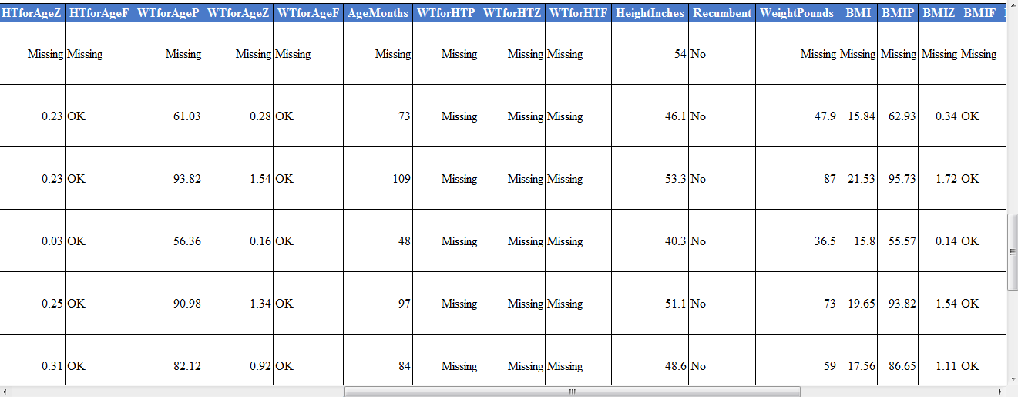
Figure 11.14: BMIZ Calculation
The code above instructs the program to assign the z-score for body mass index for age using the CDC 2000 Growth Reference to the BMIZ column. This will be done for every row in the current dataset.

The PFROMZ Function
The second Nutritional Anthropometry function included in Epi Info™ 7 is called PFROMZ, which converts a z-score into a percentile. To perform the percentile calculation, enter the column name that contains a z-score as a parameter, and the corresponding percentile is returned. For example:
PFROMZ(BMIZ)
The above code assumes the BMIZ column contains the z-scores for body mass index for age. Note that the PFROMZ function does not need to know the reference, z-score type, gender, etc., of the data. For example:
ASSIGN BMIP = PFROMZ(BMIZ)
The code above instructs the program to take the percentile associated with the z-score values stored in the BMIZ column and to assign that value to the BMIP column. This will be done for every row in the current dataset.

