Overview of report template
This template is a suggested method of presenting a brief report of the estimates of potential impact of community level interventions calculated using COVIDTracer Advanced. The user can remove, add or otherwise alter this template as needed. [Note; This is a “stand alone” copy fo material that is included in the COVIDTracer Advanced manual]

Contents of draft report

- Objective

- Summary of results

- Results: Figures and tables (in order of appearance in report)
- Figure 1: Total cases, by age group and strategy
- Figure 2: Hospitalizations averted relative to base case, by age group and ward type
- Table 1: Total hospitalizations averted, by strategy and age group
- Figure 3: Direct medical costs averted relative to base case, by age group and ward type
- Table 2: Direct medical costs averted relative to base case, by age group and ward type
- Figure 4: Medicaid expenditures averted relative to base case, by age group and ward type
- Table 3: Medicaid expenditures averted relative to base case, by age group and ward type

- Methods

- Appendices
- Description of scenarios with assumptions
- Epidemiologic parameters, and default values

Disclaimers. The numbers contained in this report should be treated as illustrations of what could happen (with unknown probability of actual occurrence). The numbers in this report, therefore, are intended solely as a guide to help public health officials and policymakers plan and prepare.

The findings and conclusions in this report and the accompanying appendices and spreadsheets are those of the author and do not necessarily represent the views of [Jurisdiction X].

This report is considered to represent technical help to the Department of Public Health, Government of Locale Y. It is not considered a publication of any form, nor has it been officially cleared by the author’s agency. The mention of any specific, commercially available product is merely to inform the reader of methods used to produce the results presented. Such mention of specific products does not constitute any endorsement.

Objective
To illustrate using jurisdiction-specific data, the potential impact of community level interventions (e.g., contact tracing and mask wearing), disaggregated into age groups, designed to mitigate transmission of COVID-19 in [Jurisdiction X]. Illustrations of impact compare a base case to three alternative community-level, public health intervention strategies in terms of estimated total cases, potential number of hospitalizations averted, potential direct medical costs averted, and Medicaid expenditures averted.

Summary of Results (Example bullet points based on COVIDTracer Advanced default values)

- Compared to current social distancing practices (base case), all three strategies that employ some level of community-based interventions reduce COVID-19 transmission across all age groups, with Strategy 3 having the largest estimated impact (Figure 1).
- Compared to the base case, all three strategies that employ some level of community-based interventions result in reduced ICU and non-ICU hospitalizations, most notably among adult populations. An estimated total 350 non-ICU hospitalizations and 137 ICU (non-ventilator) hospitalizations are averted under Strategy 3 (Figure 2 and Table 1).
- Total direct medical costs averted (all age groups and ward types) relative to the base case range from an estimated $1.5 million under Strategy 1 to an estimated $4.6 million under Strategy 3. Across all strategies, estimated costs averted are largest for adults 65+ years of age; and under Strategy 3, total direct medical costs averted for this age group are an estimated $2.5 million (Figure 3 and Table 2).

Results: Figures and tables (user copy-pastes appropriate figures from COVIDTracer Advanced)

Figure 1: Total cases, by age group and strategy
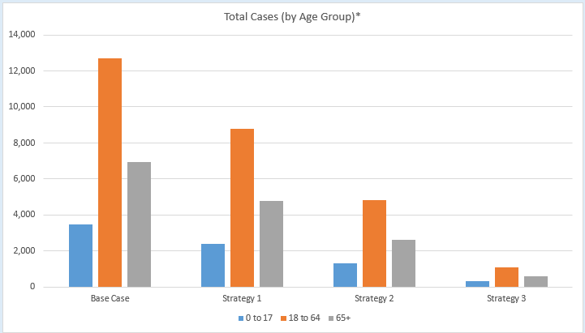

Tables and graphs (user copy-pastes appropriate figures from COVIDTracer Advanced)

Figure 2: Hospitalizations averted relative to base case, by age group and ward type
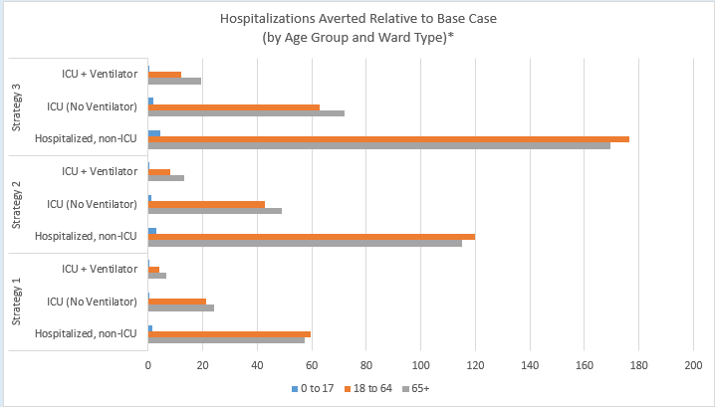

Table 1. Total hospitalizations averted, by age group and ward type
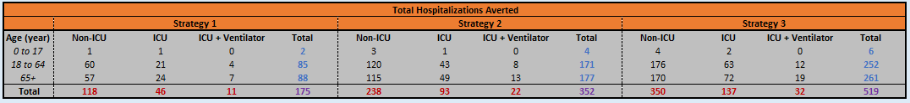

Figure 3: Direct medical costs averted relative to base case, by age group and ward type
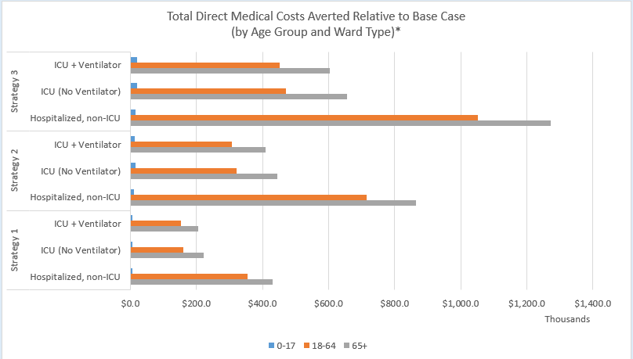

Table 2. Total direct medical costs averted relative to base case, by age group and ward type

Figure 4: Medicaid expenditures averted relative to base case, by age group and ward type
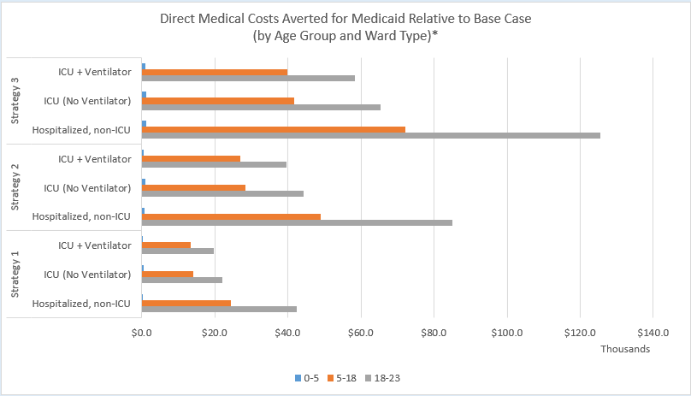

Table 3. Total Medicaid costs averted relative to base case, by age group and ward type
Methods: Used the COVIDTracer Advanced tool to produce estimates of total COVID-19 cases, hospitalizations averted, direct medical costs averted, and Medicaid expenditures averted during the period [user specifies time horizon].

Data sources used to obtain estimates: (user lists data sources or default values used for each of the input tabs listed below)

Part A. Outbreak Details;
Part B. Impact of Contact Tracing Strategies;
Part C. Contact Tracing Resources Needed;
Part D: Epidemiological Parameters (advanced/optional);
Part E.1: Hospitalization Inputs; and
Part E.2: Direct Medical Costs (i.e., costs of COVID-19 related hospitalizations).

Appendices

- Description of scenarios with assumptions
Base case: Current social distancing interventions to “flatten the curve.”
Scenario 1: Estimate the impact of the current mandates around wearing face masks combined with current contact tracing efforts.
Assumptions:
- Minimal social distancing efforts are in place, along with a mandate that masks be worn at all times by staff in restaurants and bars. The baseline R₀ is 2.0, (i.e., without any mitigation efforts each case will produce, on average 2.0 new cases).
- Case are identified and isolated on average, on the 5th day after symptom onset (i.e., on the 10th day after infection).
- The face mask and social distancing mandates currently in place reduce transmission by 15%.
Scenario 2: Estimate the impact of expanded use of face mask wearing (e.g., masks required in all indoor public spaces) and social distancing such that onward transmission is reduced by 25%, combined with improvement in contact tracing performance such that the time between symptom onset and case isolation is reduced from 5 days to 2 days.
Assumptions (some changed from situation 1):
- Social distancing efforts increase such that face masks are required to be worn by staff in all indoor businesses, reducing onward transmission by 25% due to these measures.
- Cases are identified and contact tracing begins, on average, on the 2nd days after symptom onset.
- 50% of contacts are followed up with and adhere to public health recommendations to self-monitor for symptoms and self-isolate when they arise. 50% of cases comply with isolation such that onward transmission is reduced by 20%.
- The combined reduction in transmission due to additional social distancing measures and improved contact tracing is 45%.
Scenario 3: Estimate the impact of expanded use of face mask wearing (e.g., universal mandate to wear face masks in public) such that onward transmission is reduced by 40%, combined with improvement in contact tracing performance such that the time between symptom onset and case isolation is reduced from 5 days to 2 days.
Assumptions (some changed from situations 1 & 2):
- Some social distancing efforts (e.g., reduced social mobility, face mask use) are in place such that onward transmission is reduced by 40% due to these measures.
- 50% of contacts are followed up with and adhere to public health recommendations to self-monitor for symptoms and self-isolate when they arise. 50% of cases comply with isolation such that onward transmission is reduced by 20%.
- The combined reduction in transmission due to additional social distancing measures and improved contact tracing is 60%.

B. Epidemiologic parameters, and default values
Table 1. Default values used in COVIDTracer Advanced
Epi Parameters | Default Value (Range) | Source
Infected but not yet infectious period | 3 days | CDC COVID-19 Pandemic Planning Scenarios*
Contagious (infectious) period | 11 days | He et al. (2020)
New infections per case (R₀) | 2.5 | CDC COVID-19 Pandemic Planning Scenarios*
Change in case growth over the last 14 days | R_{t} = 1.8 (Rapidly increasing)  R_{t} = 1.2 (Slowly increasing)  Default R_{t} = 1.0 (Plateaued)  R_{t} = 0.8 (Slowly decreasing)  R_{t} = 0.33 (Rapidly decreasing) | Assumed
% cases that are asymptomatic | 40% | CDC COVID-19 Pandemic Planning Scenarios*
Relative infectiousness of asymptomatic cases (to symptomatic cases) | 75% | CDC COVID-19 Pandemic Planning Scenarios*
Number of contacts per case** | Upper: 5  Lower: 20 | Assumed
* CDC COVID-19 Pandemic Planning Scenarios. https://www.cdc.gov/coronavirus/2019-ncov/hcp/planning-scenarios.html .

